DATABASE MANAGEMENT SYSTEM
SMART CAMPUS MANAGEMENT SYSTEM
Complete Project Reference Report
Submitted for Academic Evaluation
Submitted by | Vishal Prajapati
Roll Number | FDAI044-A
Class | FY-BSC AI
Subject | Database Management Systems (DBMS)
Faculty In-charge | Onkar Raotole
Submission Date | 31 August 2026
Important print instruction
Write the short explanatory portions manually. Print the marked SQL-code and query-output assets from the assets folder and attach them as evidence; do not handwrite the marked screenshots.

TABLE OF CONTENTS / INDEX
Part / Section | What the student writes or attaches
Cover Page | Student details and academic information
Part A – Requirement Analysis | Objectives, users, functional requirements, non-functional requirements
Part B – Database Design | Chosen modules, ER diagram, relational schema, keys, and 3NF
Part C – Database Implementation | Database setup, table definitions, and constraints
Part D – Data Entry | Insert strategy and record-count evidence
Part E – SQL Queries | 45 queries; each query is followed by its output screenshot
Part F – Report | Challenges, learning outcomes, conclusion, and references
Printable Asset Index | Source-code screenshots and all query-output screenshots

How to use this reference
The report is intentionally detailed so the student can copy the concise written explanations. Anything labelled [PRINT THIS ASSET] is supplied in the assets folder for printing and attaching.

PART A – REQUIREMENT ANALYSIS

A1. Objectives
The objective is to design and implement a relational Smart Campus Management System. It centralizes academic and placement information and applies keys, constraints, normalization, and SQL queries for reliable data management.

A2. Users of the System
User | Responsibilities
Administrator | Maintains database structure, departments, users, and records.
Faculty | Views course rosters and records attendance and marks.
Student | Views profile, attendance, results, and placement information.
Placement Officer | Manages drives, eligibility, and application status.

A3. Functional Requirements
- The system shall store department, student, faculty, course, attendance, examination, result, and placement information.
- The system shall support insertion, retrieval, update, deletion, and schema alteration operations.
- The system shall answer analytical questions using aggregate, JOIN, nested, and pattern-matching queries.

A4. Non-Functional Requirements
Requirement | Short description
Integrity | Use PRIMARY KEY, FOREIGN KEY, UNIQUE, NOT NULL, CHECK, and DEFAULT constraints.
Performance | Support routine reports using efficient relational queries.
Scalability | Allow more students, courses, departments, and placement drives.
Maintainability | Use clear names, normalized tables, and documented SQL.

PART B – DATABASE DESIGN

B1. Selected Modules
Module | Tables | Purpose
Student Management | Student | Identity, admission, contact, and CGPA
Faculty Management | Faculty | Faculty, department, designation, and salary
Attendance | Attendance | Student attendance by course and date
Examination and Result | Examination, Result | Exam schedules, marks, and grades
Placement Cell | Placement_Drive, Placement_Record | Recruitment drives and applications

B2. Relationship Summary
Department connects to Student, Faculty, and Course. Course connects to Attendance and Examination. Result connects students with examinations. Placement_Record connects students with Placement_Drive. Foreign keys preserve these relationships.
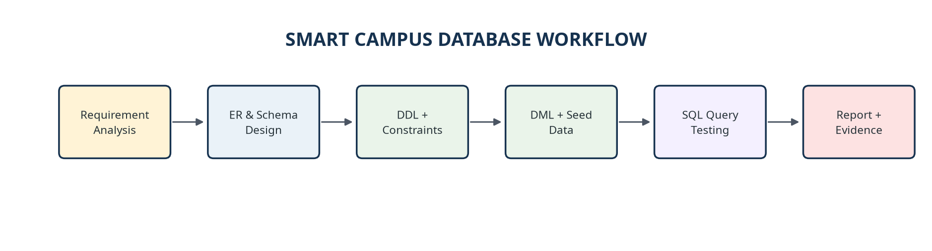
Figure B1. Database project workflow.
[PRINT THIS ASSET: assets/smart_campus_workflow.png]
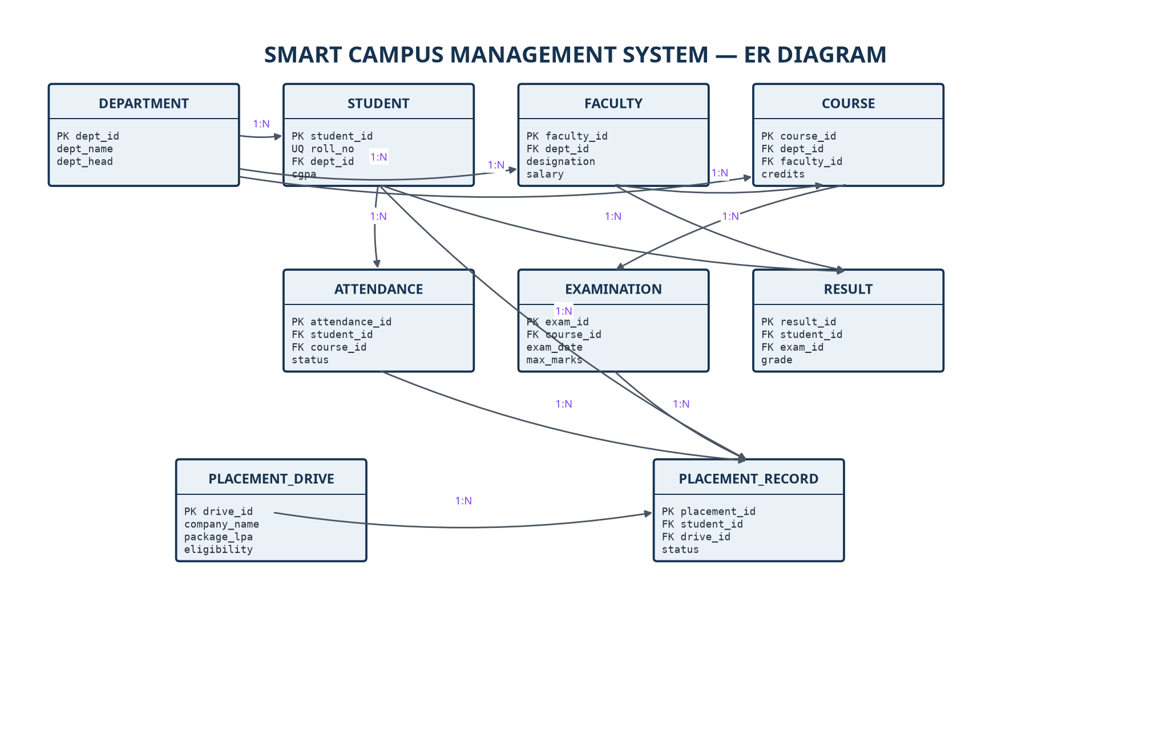
Figure B2. Entity-Relationship diagram.
[PRINT THIS ASSET: assets/smart_campus_er_diagram.png]

PART B – RELATIONAL SCHEMA, KEYS, AND NORMALIZATION

B3. Relational Schema and Key Mapping
Table | Primary key | Foreign key mapping
Department | dept_id | —
Student | student_id | dept_id → Department
Faculty | faculty_id | dept_id → Department
Course | course_id | dept_id → Department; faculty_id → Faculty
Attendance | attendance_id | student_id → Student; course_id → Course
Examination | exam_id | course_id → Course
Result | result_id | student_id → Student; exam_id → Examination
Placement_Drive | drive_id | —
Placement_Record | placement_id | student_id → Student; drive_id → Placement_Drive

B4. Normalization up to Third Normal Form
Normal form | Application
1NF | Each field contains one atomic value and every row has a primary key.
2NF | Non-key attributes depend on the complete key; transaction tables use unique combinations.
3NF | Department and faculty information are separated so non-key attributes do not depend on other non-key attributes.

Short handwritten explanation
Normalization reduces repetition and prevents update, insertion, and deletion anomalies.

PART C – DATABASE IMPLEMENTATION

C1. Database Setup
01 DROP DATABASE IF EXISTS smart_campus_db;
02 CREATE DATABASE smart_campus_db;
03 USE smart_campus_db;

C2. Representative Table Definition
01 CREATE TABLE Student (
02 student_id INT PRIMARY KEY AUTO_INCREMENT,
03 roll_no VARCHAR(15) NOT NULL UNIQUE,
04 full_name VARCHAR(60) NOT NULL,
05 dept_id INT,
06 cgpa DECIMAL(3,2) DEFAULT 0.00 CHECK (cgpa BETWEEN 0 AND 10),
07 FOREIGN KEY (dept_id) REFERENCES Department(dept_id)
08 ON DELETE SET NULL
09 );

C3. Constraint Checklist
Constraint | Example | Purpose
PRIMARY KEY | student_id | Unique row identity
FOREIGN KEY | REFERENCES Department(dept_id) | Referential integrity
UNIQUE | roll_no UNIQUE | Prevents duplicate values
NOT NULL | full_name NOT NULL | Requires essential data
CHECK | cgpa BETWEEN 0 AND 10 | Validates allowed range
DEFAULT | status DEFAULT 'Applied' | Safe fallback value

The complete DDL is available in the attached SQL source file and in the printable source-code screenshots listed later in this report.

PART D – DATA ENTRY
Seed data is inserted after the parent tables are created. This allows all foreign-key references to resolve correctly. The initial insert blocks in the source file provide the following record coverage:
Table | Initial inserted records | Use
Department | 6 | Department master data
Student | 20 | Student records
Faculty | 20 | Faculty records
Course | 20 | Course offerings
Attendance | 30 | Attendance events
Examination | 20 | Exam schedules
Result | 25 | Marks and grades
Placement_Drive | 15 | Recruitment drives
Placement_Record | 20 | Applications

D1. Data Entry Logic
- Insert department records before student, faculty, and course records.
- Insert student and faculty records with unique roll numbers and emails.
- Insert courses and then add attendance, examination, result, and placement records.
- Use valid foreign-key values and allowed status, gender, CGPA, and salary ranges.
Evidence note
The UPDATE and DELETE demonstrations are separate operations. Therefore, the final database snapshot after executing the full script may have fewer rows in tables affected by demonstration DELETE statements.

PART E – SQL QUERIES
The teacher requires 45 SQL queries. The source file includes exactly 45 statements divided into eight categories. For every query below, the SQL statement is shown first and its independently verified output screenshot is placed immediately below it.
Category | Required | Included
Retrieval Queries | 10 | 10
Aggregate Function Queries | 5 | 5
JOIN Queries | 5 | 5
Nested / Subquery Queries | 5 | 5
UPDATE Queries | 5 | 5
DELETE Queries | 5 | 5
ALTER TABLE Queries | 5 | 5
Pattern Matching / LIKE Queries | 5 | 5

Print convention
Every query screenshot has a matching file inside assets/query_outputs/. Print the file named in the bracket immediately below the screenshot and attach it to the written report.

PART E – SQL QUERY EVIDENCE

Query 1.1 — Show all students
Category: Retrieval. Purpose: Show all students. The statement below is taken from the published SQL source.
01 SELECT * FROM Student;

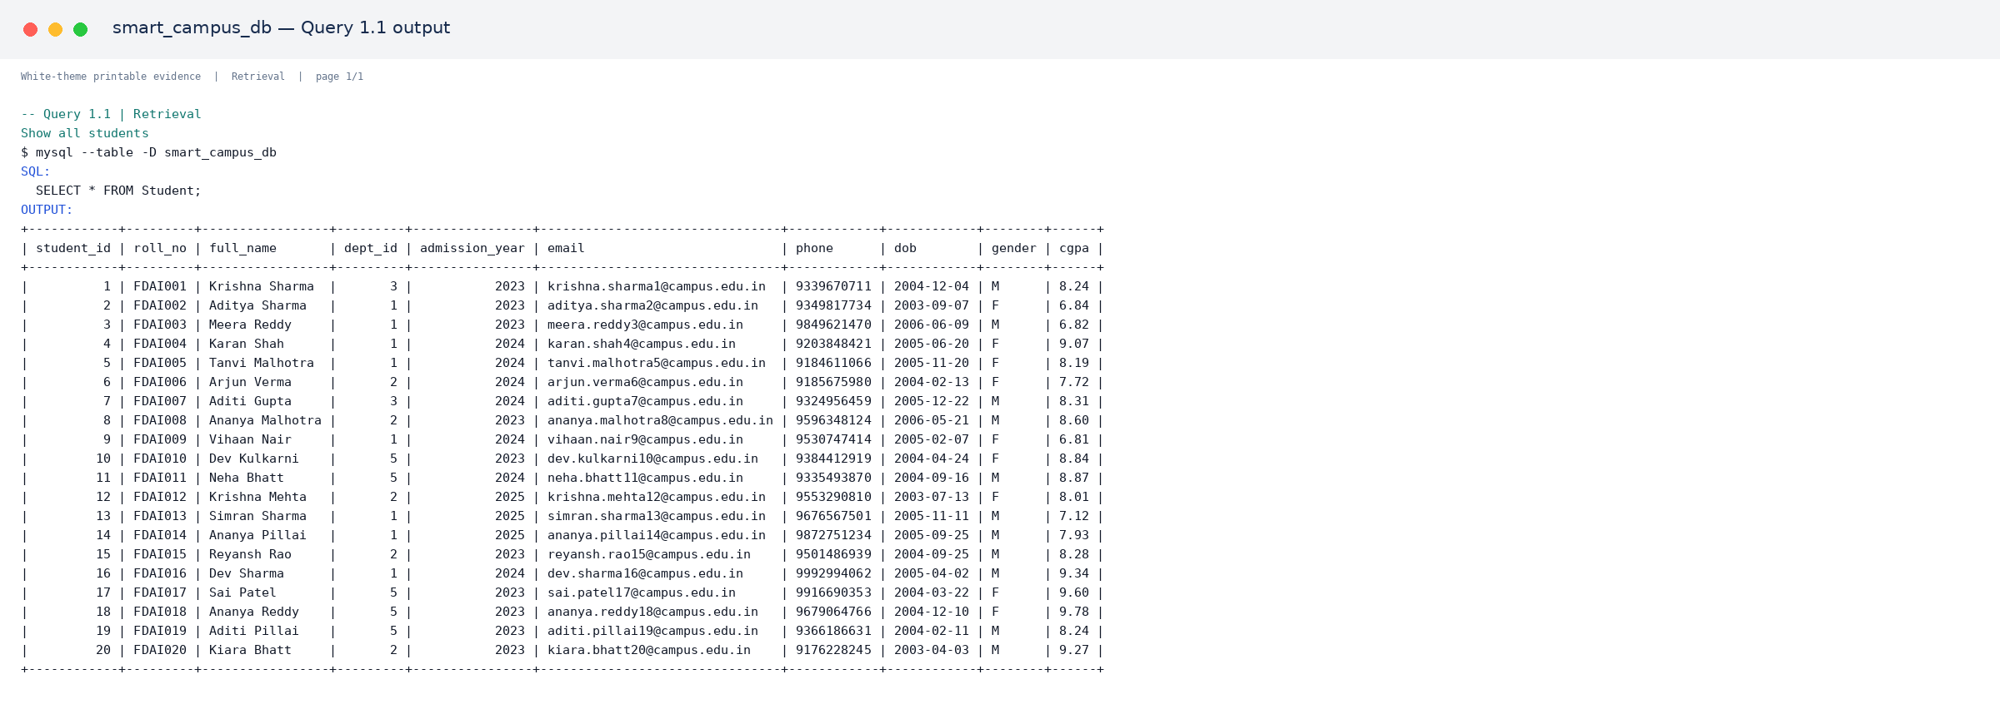
Output 1.1.1. Verified MySQL output for Query 1.1.
[PRINT THIS ASSET: assets/query_outputs/q01_01_retrieval_output_01.png]

Query 1.2 — Show name, roll number and cgpa of students, highest cgpa first
Category: Retrieval. Purpose: Show name, roll number and cgpa of students, highest cgpa first. The statement below is taken from the published SQL source.
01 SELECT full_name, roll_no, cgpa FROM Student ORDER BY cgpa DESC;

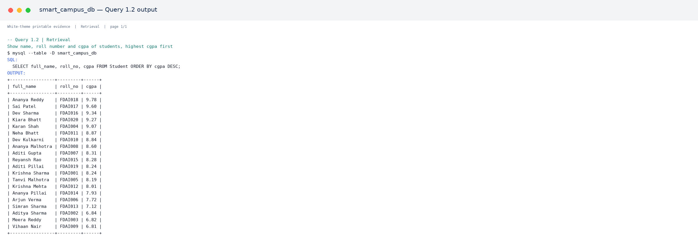
Output 1.2.1. Verified MySQL output for Query 1.2.
[PRINT THIS ASSET: assets/query_outputs/q01_02_retrieval_output_01.png]

PART E – SQL QUERY EVIDENCE

Query 1.3 — Show all faculty members from the Artificial Intelligence department
Category: Retrieval. Purpose: Show all faculty members from the Artificial Intelligence department. The statement below is taken from the published SQL source.
01 SELECT full_name, designation, email
02 FROM Faculty
03 WHERE dept_id = (SELECT dept_id FROM Department WHERE dept_name = 'Artificial Intelligence');

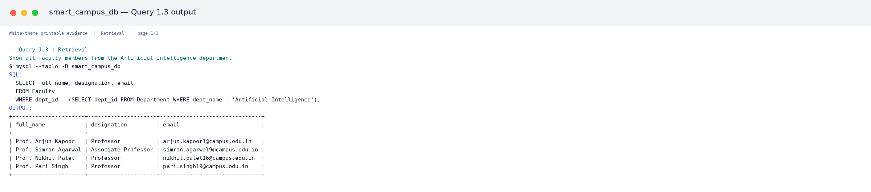
Output 1.3.1. Verified MySQL output for Query 1.3.
[PRINT THIS ASSET: assets/query_outputs/q01_03_retrieval_output_01.png]

Query 1.4 — Show students who took admission in 2024
Category: Retrieval. Purpose: Show students who took admission in 2024. The statement below is taken from the published SQL source.
01 SELECT roll_no, full_name, admission_year FROM Student WHERE admission_year = 2024;

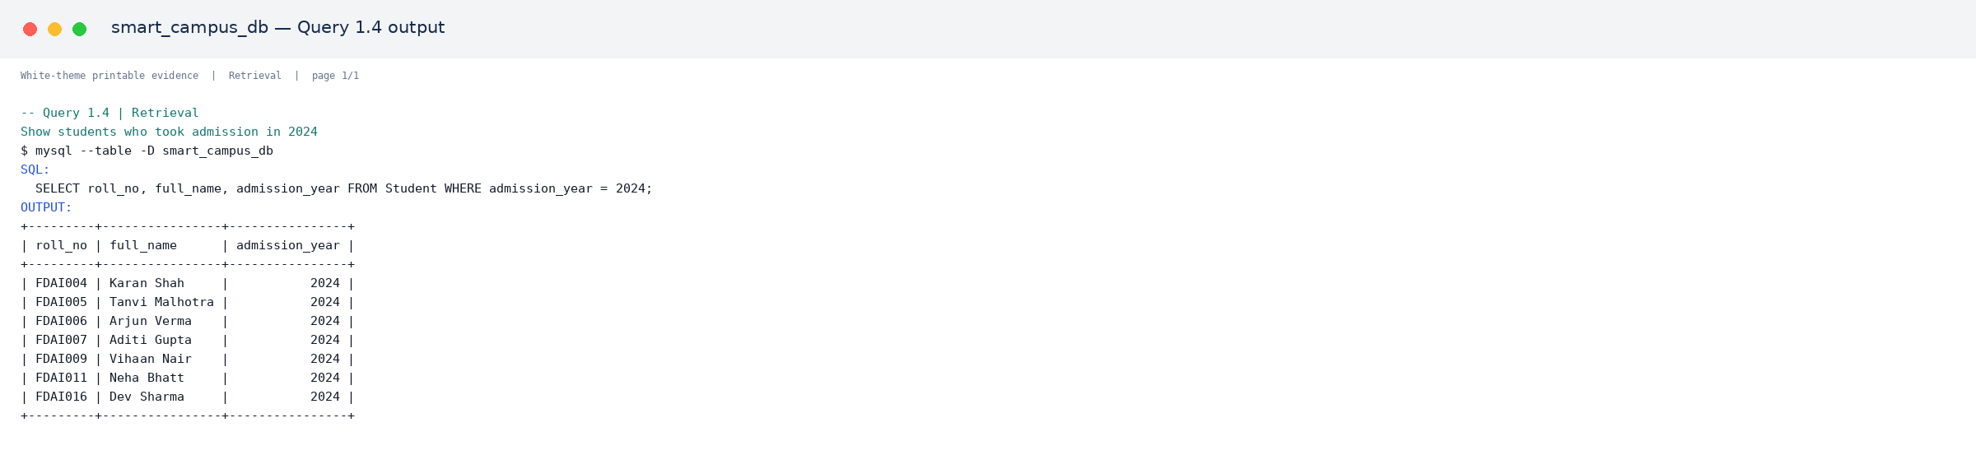
Output 1.4.1. Verified MySQL output for Query 1.4.
[PRINT THIS ASSET: assets/query_outputs/q01_04_retrieval_output_01.png]

PART E – SQL QUERY EVIDENCE

Query 1.5 — Show all courses that carry 4 credits
Category: Retrieval. Purpose: Show all courses that carry 4 credits. The statement below is taken from the published SQL source.
01 SELECT course_name, credits, semester FROM Course WHERE credits = 4;

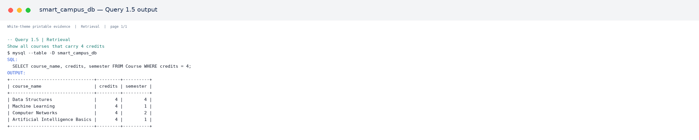
Output 1.5.1. Verified MySQL output for Query 1.5.
[PRINT THIS ASSET: assets/query_outputs/q01_05_retrieval_output_01.png]

Query 1.6 — Show all placement drives offering package above 8 LPA
Category: Retrieval. Purpose: Show all placement drives offering package above 8 LPA. The statement below is taken from the published SQL source.
01 SELECT company_name, drive_date, package_offered FROM Placement_Drive WHERE package_offered > 8;

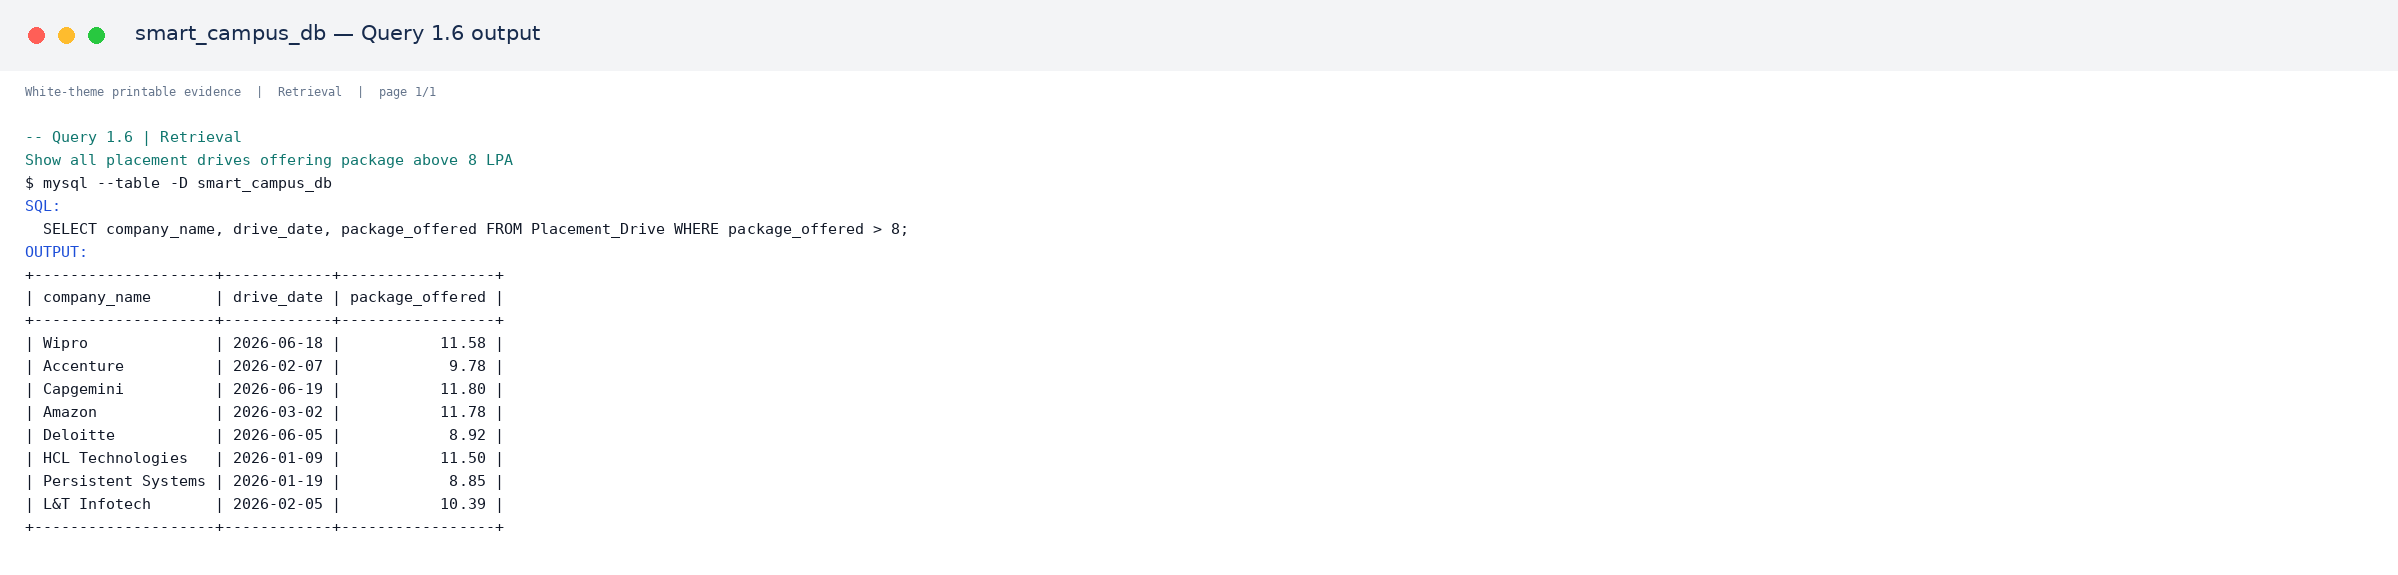
Output 1.6.1. Verified MySQL output for Query 1.6.
[PRINT THIS ASSET: assets/query_outputs/q01_06_retrieval_output_01.png]

PART E – SQL QUERY EVIDENCE

Query 1.7 — Show top 5 students by cgpa
Category: Retrieval. Purpose: Show top 5 students by cgpa. The statement below is taken from the published SQL source.
01 SELECT full_name, roll_no, cgpa FROM Student ORDER BY cgpa DESC LIMIT 5;

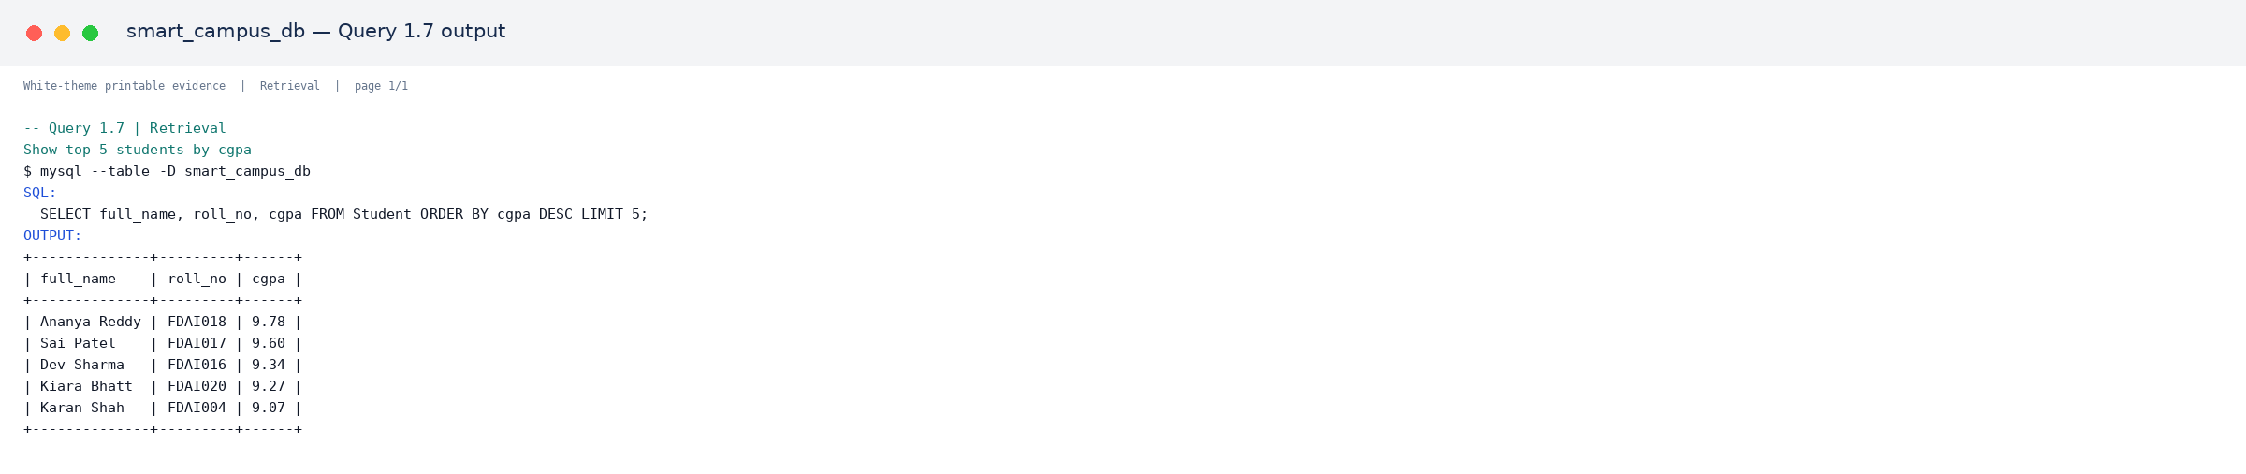
Output 1.7.1. Verified MySQL output for Query 1.7.
[PRINT THIS ASSET: assets/query_outputs/q01_07_retrieval_output_01.png]

Query 1.8 — Show all exams scheduled after 1st May 2026
Category: Retrieval. Purpose: Show all exams scheduled after 1st May 2026. The statement below is taken from the published SQL source.
01 SELECT exam_name, exam_date, max_marks FROM Examination WHERE exam_date > '2026-05-01';

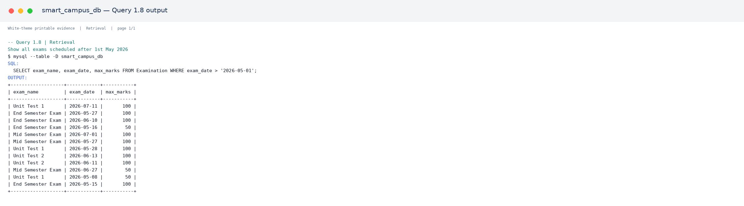
Output 1.8.1. Verified MySQL output for Query 1.8.
[PRINT THIS ASSET: assets/query_outputs/q01_08_retrieval_output_01.png]

PART E – SQL QUERY EVIDENCE

Query 1.9 — Show student details along with their department name
Category: Retrieval. Purpose: Show student details along with their department name. The statement below is taken from the published SQL source.
01 SELECT s.roll_no, s.full_name, d.dept_name
02 FROM Student s, Department d
03 WHERE s.dept_id = d.dept_id;

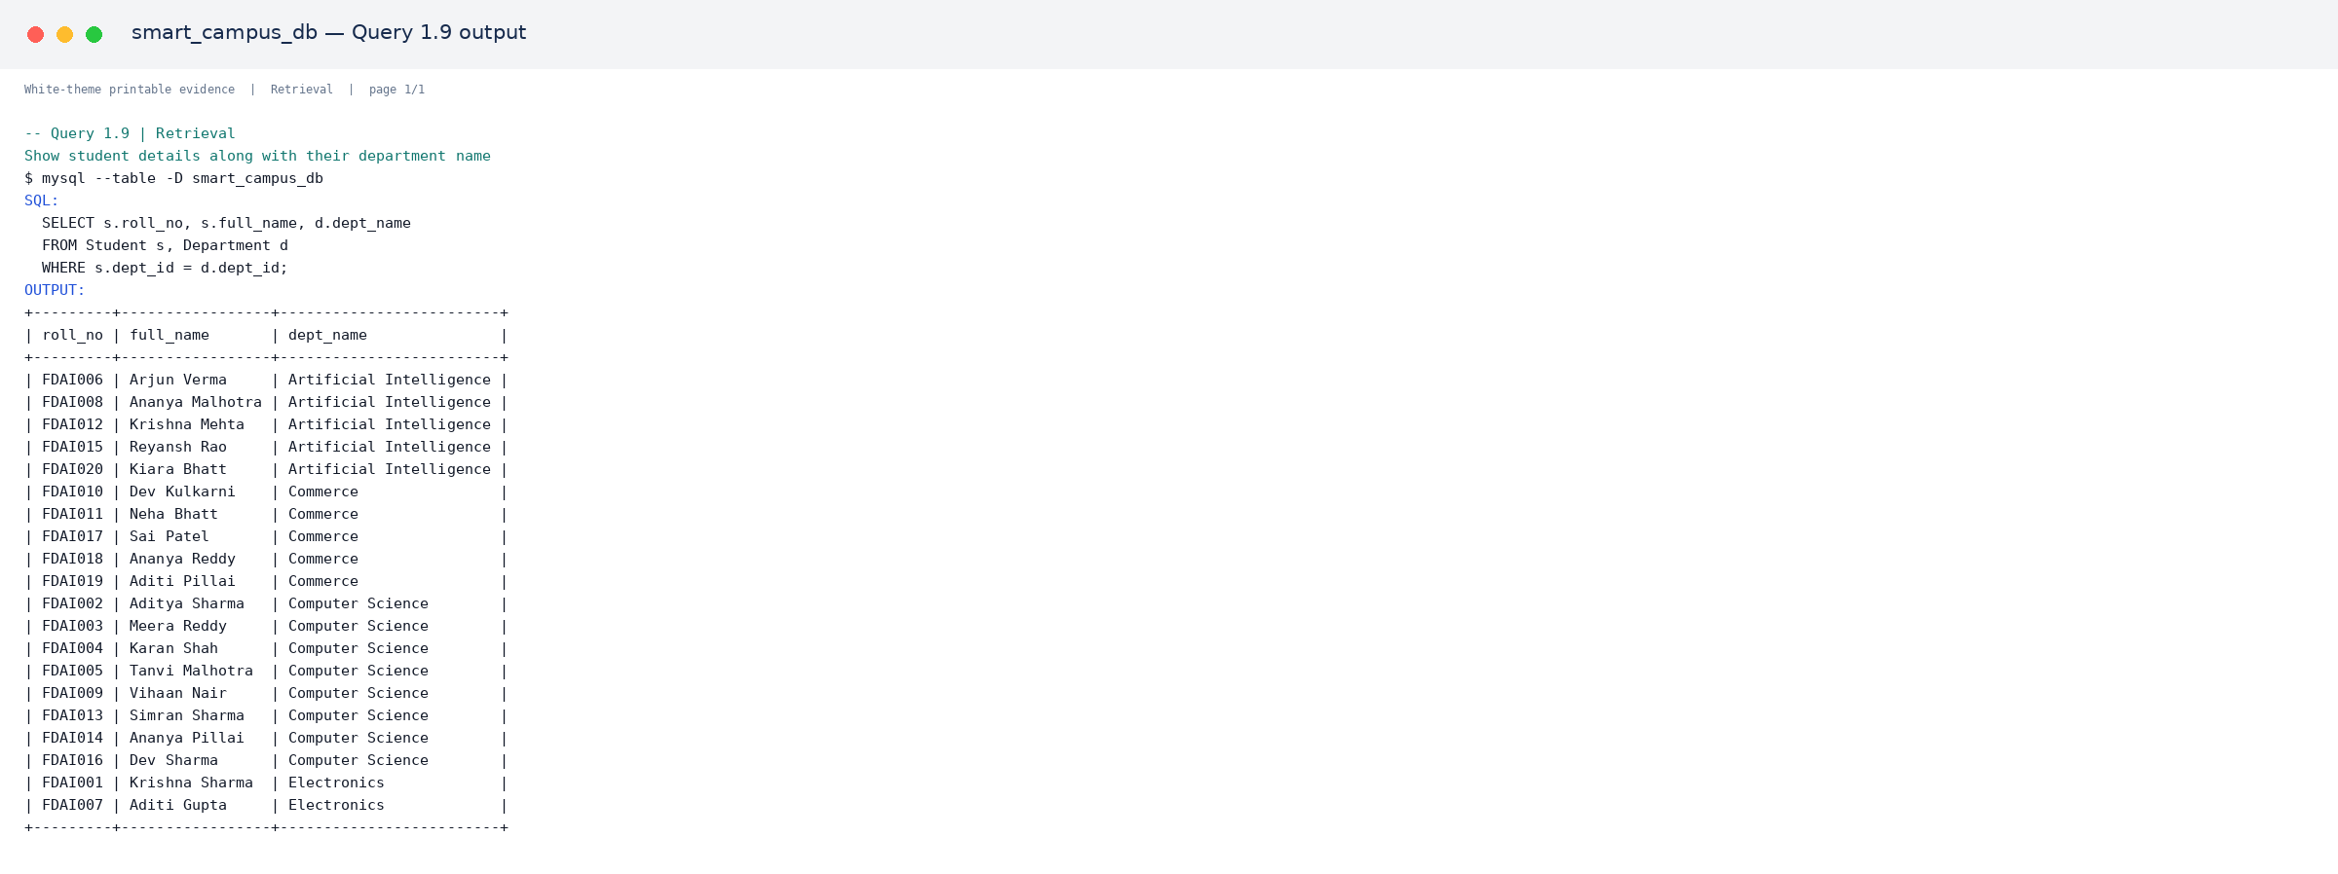
Output 1.9.1. Verified MySQL output for Query 1.9.
[PRINT THIS ASSET: assets/query_outputs/q01_09_retrieval_output_01.png]

Query 1.10 — Show distinct designations used by faculty members
Category: Retrieval. Purpose: Show distinct designations used by faculty members. The statement below is taken from the published SQL source.
01 SELECT DISTINCT designation FROM Faculty;
02
03
04 -- ***********************************************************
05 -- 2. AGGREGATE FUNCTION QUERIES (5)
06 -- ***********************************************************

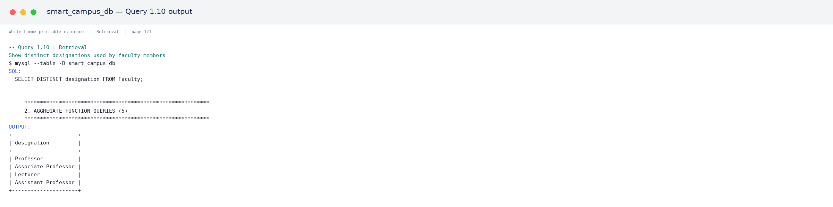
Output 1.10.1. Verified MySQL output for Query 1.10.
[PRINT THIS ASSET: assets/query_outputs/q01_10_retrieval_output_01.png]

PART E – SQL QUERY EVIDENCE

Query 2.1 — Total number of students in the campus
Category: Aggregate Function. Purpose: Total number of students in the campus. The statement below is taken from the published SQL source.
01 SELECT COUNT(*) AS total_students FROM Student;

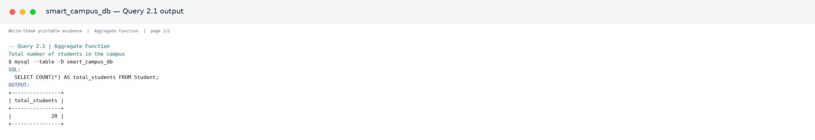
Output 2.1.1. Verified MySQL output for Query 2.1.
[PRINT THIS ASSET: assets/query_outputs/q02_01_aggregate_output_01.png]

Query 2.2 — Average cgpa of all students
Category: Aggregate Function. Purpose: Average cgpa of all students. The statement below is taken from the published SQL source.
01 SELECT ROUND(AVG(cgpa),2) AS average_cgpa FROM Student;

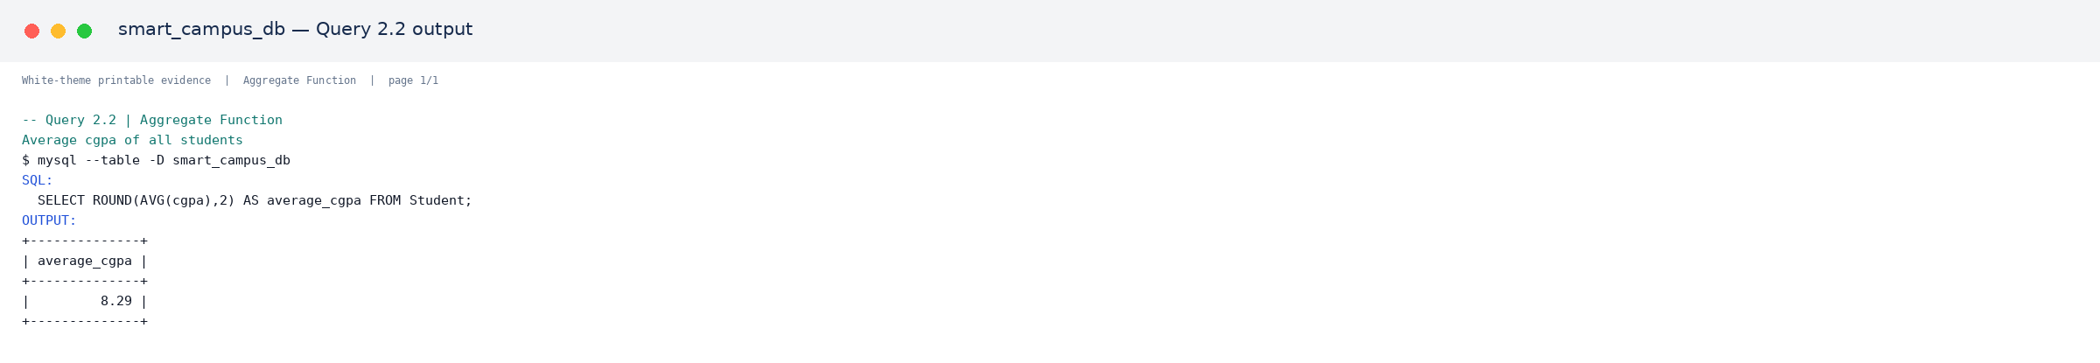
Output 2.2.1. Verified MySQL output for Query 2.2.
[PRINT THIS ASSET: assets/query_outputs/q02_02_aggregate_output_01.png]

Query 2.3 — Highest and lowest package offered across all placement drives
Category: Aggregate Function. Purpose: Highest and lowest package offered across all placement drives. The statement below is taken from the published SQL source.
01 SELECT MAX(package_offered) AS highest_package, MIN(package_offered) AS lowest_package
02 FROM Placement_Drive;

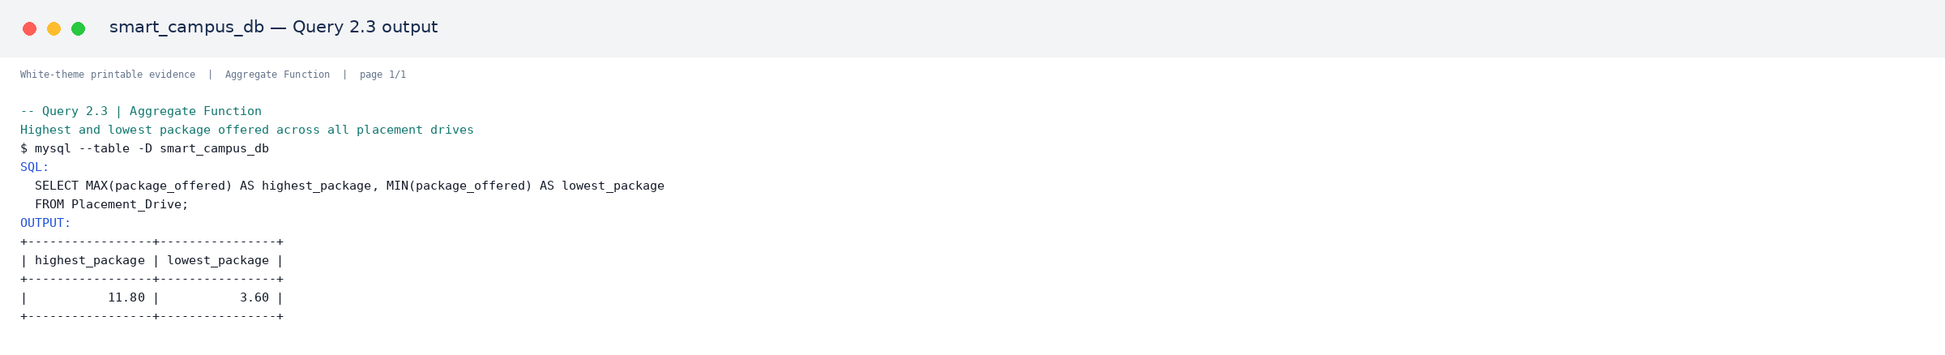
Output 2.3.1. Verified MySQL output for Query 2.3.
[PRINT THIS ASSET: assets/query_outputs/q02_03_aggregate_output_01.png]

PART E – SQL QUERY EVIDENCE

Query 2.4 — Number of students in each department
Category: Aggregate Function. Purpose: Number of students in each department. The statement below is taken from the published SQL source.
01 SELECT d.dept_name, COUNT(s.student_id) AS total_students
02 FROM Department d
03 LEFT JOIN Student s ON d.dept_id = s.dept_id
04 GROUP BY d.dept_name;

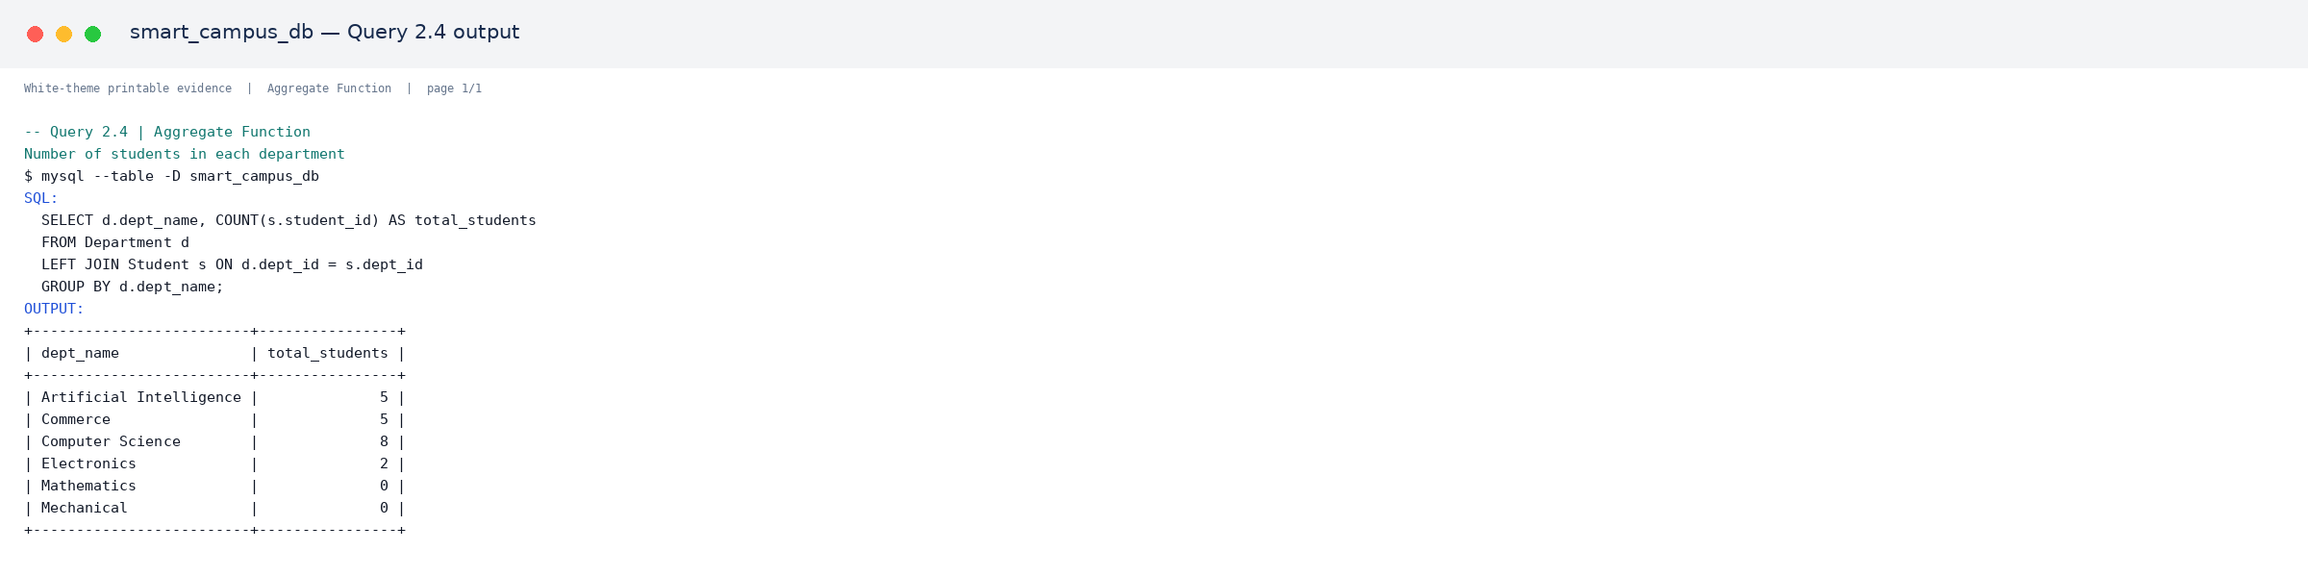
Output 2.4.1. Verified MySQL output for Query 2.4.
[PRINT THIS ASSET: assets/query_outputs/q02_04_aggregate_output_01.png]

Query 2.5 — Total salary paid by the campus to faculty of each department
Category: Aggregate Function. Purpose: Total salary paid by the campus to faculty of each department. The statement below is taken from the published SQL source.
01 SELECT d.dept_name, SUM(f.salary) AS total_salary
02 FROM Department d
03 JOIN Faculty f ON d.dept_id = f.dept_id
04 GROUP BY d.dept_name;
05
06
07 -- ***********************************************************
08 -- 3. JOIN QUERIES (5)
09 -- ***********************************************************

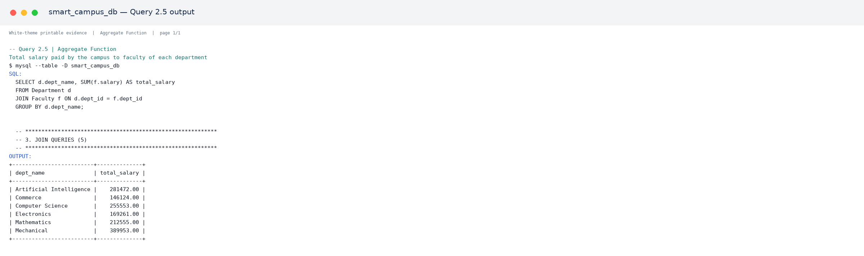
Output 2.5.1. Verified MySQL output for Query 2.5.
[PRINT THIS ASSET: assets/query_outputs/q02_05_aggregate_output_01.png]

PART E – SQL QUERY EVIDENCE

Query 3.1 — List every student with the course they attend and the class faculty (INNER JOIN, 3 tables)
Category: JOIN. Purpose: List every student with the course they attend and the class faculty (INNER JOIN, 3 tables). The statement below is taken from the published SQL source.
01 SELECT s.full_name AS student, c.course_name, f.full_name AS faculty
02 FROM Attendance a
03 JOIN Student s ON a.student_id = s.student_id
04 JOIN Course c ON a.course_id = c.course_id
05 JOIN Faculty f ON c.faculty_id = f.faculty_id;

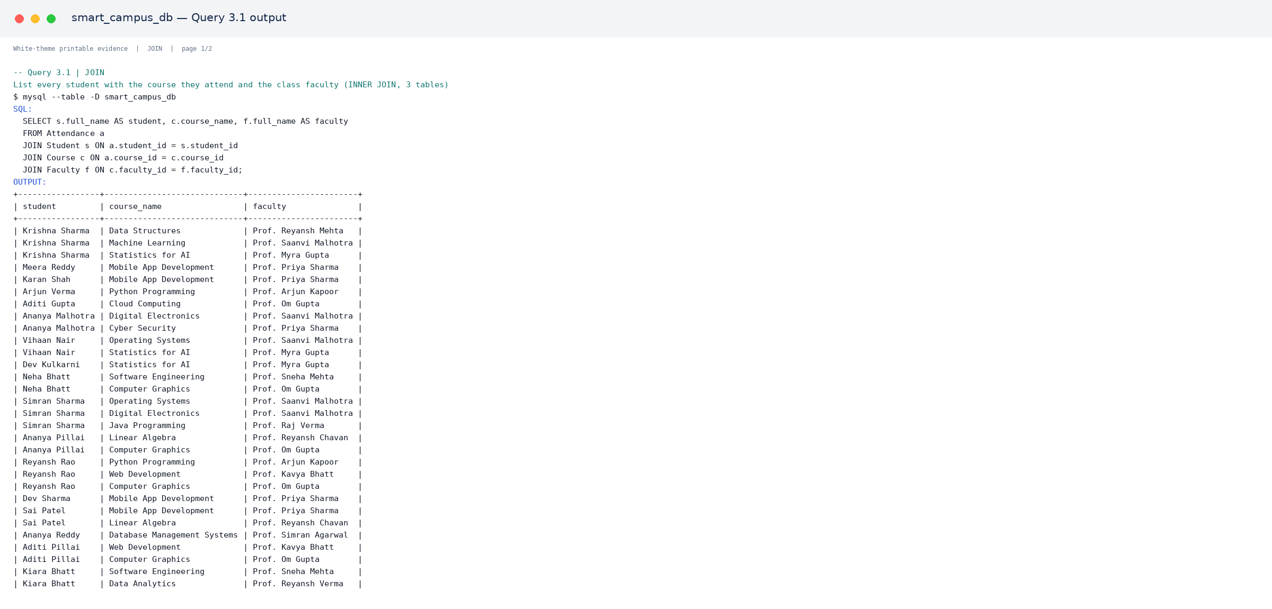
Output 3.1.1. Verified MySQL output for Query 3.1.
[PRINT THIS ASSET: assets/query_outputs/q03_01_join_output_01.png]
Output 3.1.2. Verified MySQL output for Query 3.1.
[PRINT THIS ASSET: assets/query_outputs/q03_01_join_output_02.png]

PART E – SQL QUERY EVIDENCE

Query 3.2 — List each student's marks together with the exam and course name
Category: JOIN. Purpose: List each student's marks together with the exam and course name. The statement below is taken from the published SQL source.
01 SELECT s.full_name AS student, e.exam_name, c.course_name, r.marks_obtained, r.grade
02 FROM Result r
03 JOIN Student s ON r.student_id = s.student_id
04 JOIN Examination e ON r.exam_id = e.exam_id
05 JOIN Course c ON e.course_id = c.course_id;

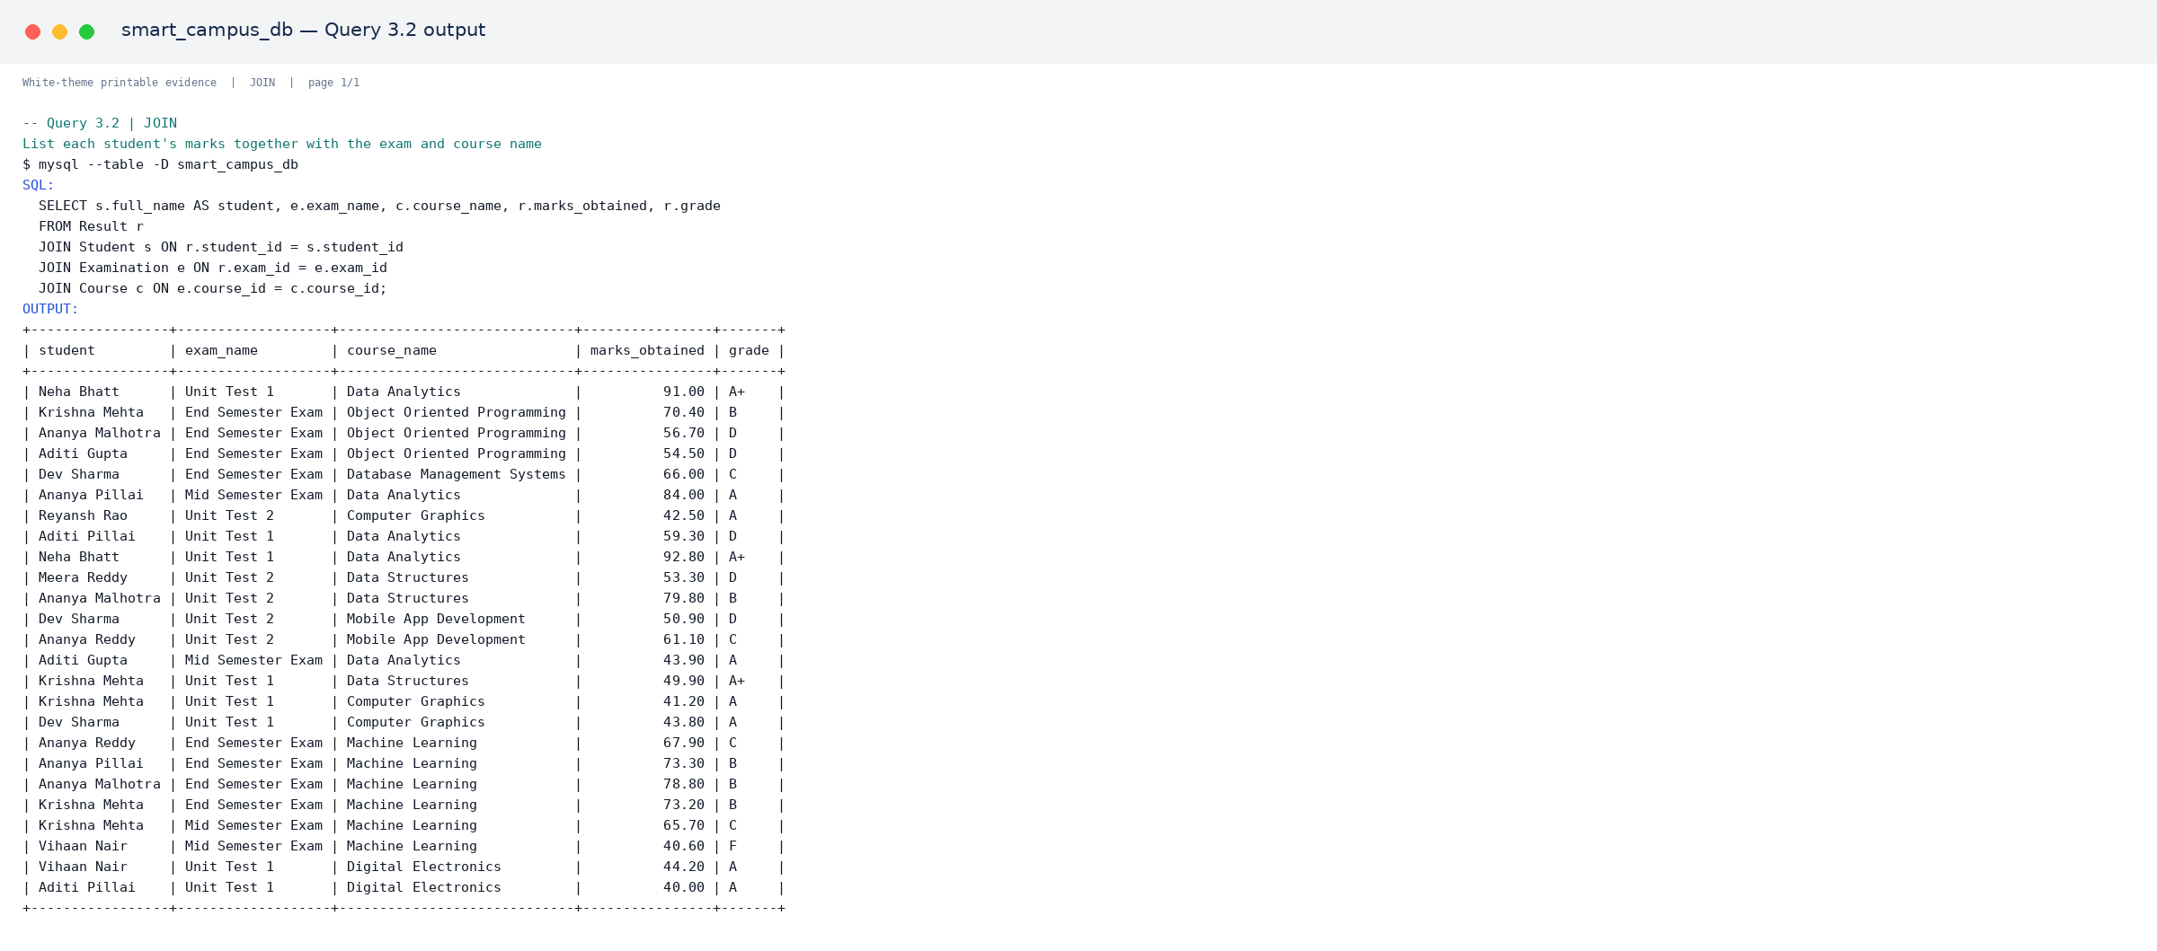
Output 3.2.1. Verified MySQL output for Query 3.2.
[PRINT THIS ASSET: assets/query_outputs/q03_02_join_output_01.png]

PART E – SQL QUERY EVIDENCE

Query 3.3 — LEFT JOIN - show every student even if they never applied for placement
Category: JOIN. Purpose: LEFT JOIN - show every student even if they never applied for placement. The statement below is taken from the published SQL source.
01 SELECT s.full_name, pd.company_name, pr.status
02 FROM Student s
03 LEFT JOIN Placement_Record pr ON s.student_id = pr.student_id
04 LEFT JOIN Placement_Drive pd ON pr.drive_id = pd.drive_id
05 ORDER BY s.full_name;

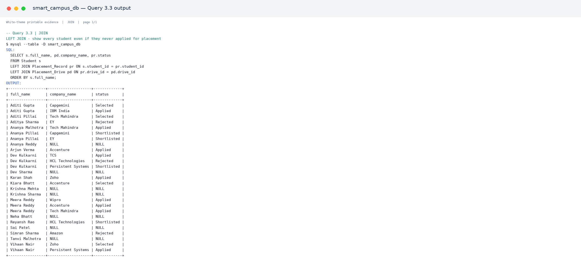
Output 3.3.1. Verified MySQL output for Query 3.3.
[PRINT THIS ASSET: assets/query_outputs/q03_03_join_output_01.png]

PART E – SQL QUERY EVIDENCE

Query 3.4 — List courses along with the department and the faculty teaching them
Category: JOIN. Purpose: List courses along with the department and the faculty teaching them. The statement below is taken from the published SQL source.
01 SELECT c.course_name, d.dept_name, f.full_name AS faculty_name
02 FROM Course c
03 JOIN Department d ON c.dept_id = d.dept_id
04 JOIN Faculty f ON c.faculty_id = f.faculty_id;

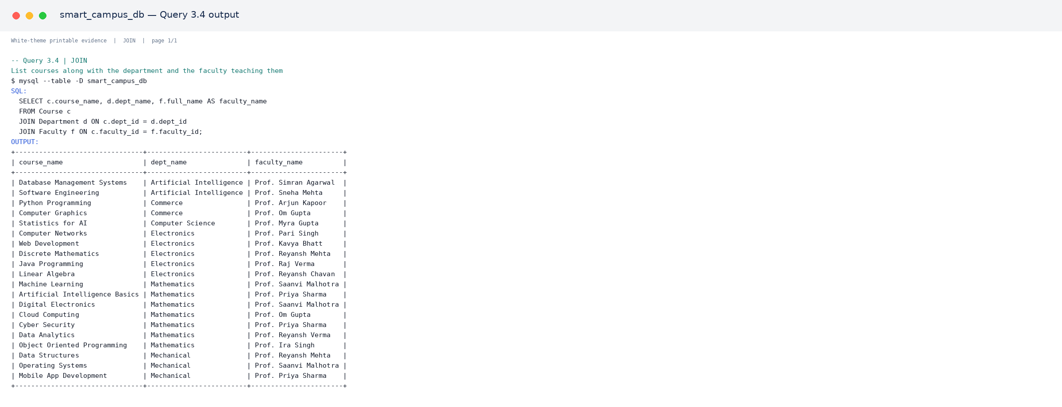
Output 3.4.1. Verified MySQL output for Query 3.4.
[PRINT THIS ASSET: assets/query_outputs/q03_04_join_output_01.png]

PART E – SQL QUERY EVIDENCE

Query 3.5 — RIGHT JOIN - show all placement drives and the students placed in them, if any
Category: JOIN. Purpose: RIGHT JOIN - show all placement drives and the students placed in them, if any. The statement below is taken from the published SQL source.
01 SELECT pd.company_name, s.full_name, pr.status
02 FROM Placement_Record pr
03 RIGHT JOIN Placement_Drive pd ON pr.drive_id = pd.drive_id
04 LEFT JOIN Student s ON pr.student_id = s.student_id;
05
06
07 -- ***********************************************************
08 -- 4. NESTED (SUBQUERY) QUERIES (5)
09 -- ***********************************************************

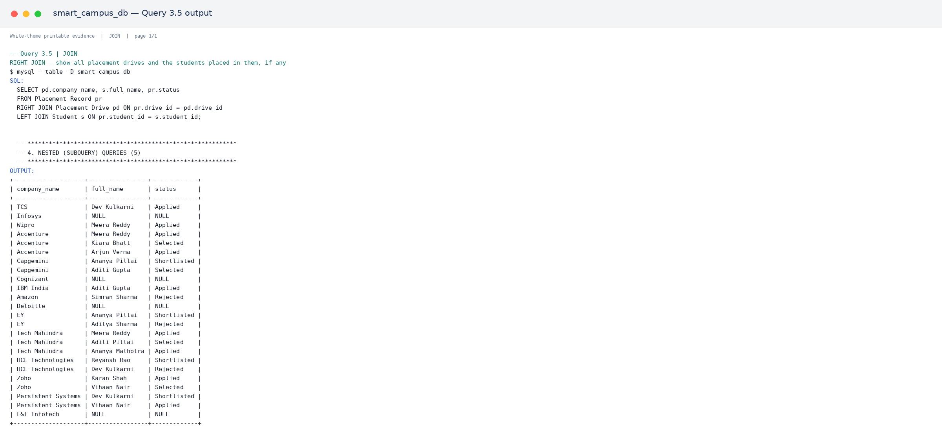
Output 3.5.1. Verified MySQL output for Query 3.5.
[PRINT THIS ASSET: assets/query_outputs/q03_05_join_output_01.png]

PART E – SQL QUERY EVIDENCE

Query 4.1 — Students whose cgpa is above the campus average
Category: Nested Query. Purpose: Students whose cgpa is above the campus average. The statement below is taken from the published SQL source.
01 SELECT full_name, cgpa
02 FROM Student
03 WHERE cgpa > (SELECT AVG(cgpa) FROM Student);

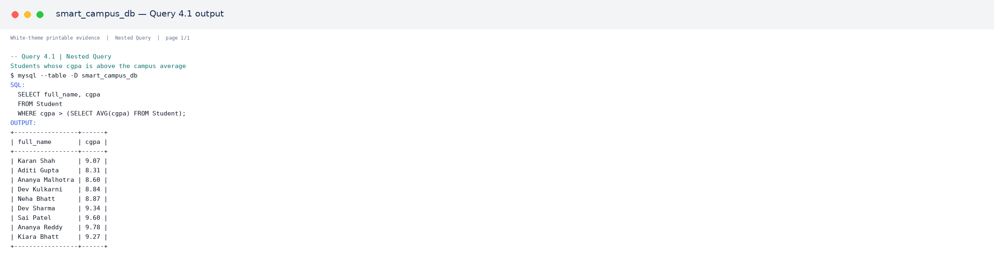
Output 4.1.1. Verified MySQL output for Query 4.1.
[PRINT THIS ASSET: assets/query_outputs/q04_01_nested_query_output_01.png]

Query 4.2 — Faculty who earn more than the average salary of their own department
Category: Nested Query. Purpose: Faculty who earn more than the average salary of their own department. The statement below is taken from the published SQL source.
01 SELECT full_name, dept_id, salary
02 FROM Faculty f
03 WHERE salary > (
04 SELECT AVG(salary) FROM Faculty WHERE dept_id = f.dept_id
05 );

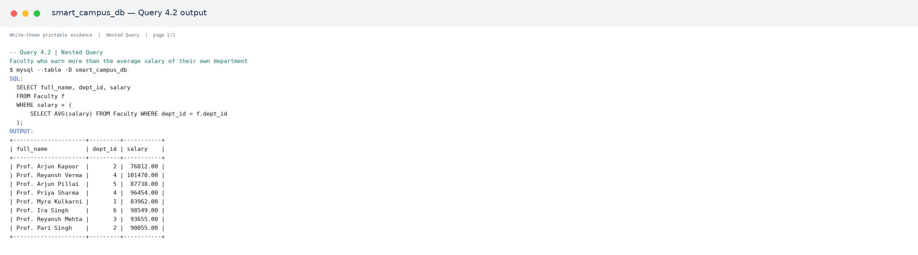
Output 4.2.1. Verified MySQL output for Query 4.2.
[PRINT THIS ASSET: assets/query_outputs/q04_02_nested_query_output_01.png]

PART E – SQL QUERY EVIDENCE

Query 4.3 — Students who have been selected in at least one placement drive
Category: Nested Query. Purpose: Students who have been selected in at least one placement drive. The statement below is taken from the published SQL source.
01 SELECT full_name, roll_no
02 FROM Student
03 WHERE student_id IN (
04 SELECT student_id FROM Placement_Record WHERE status = 'Selected'
05 );

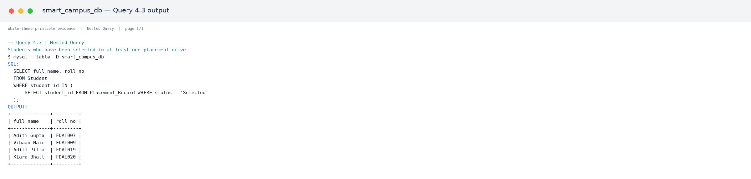
Output 4.3.1. Verified MySQL output for Query 4.3.
[PRINT THIS ASSET: assets/query_outputs/q04_03_nested_query_output_01.png]

Query 4.4 — Courses that currently have no exam scheduled
Category: Nested Query. Purpose: Courses that currently have no exam scheduled. The statement below is taken from the published SQL source.
01 SELECT course_name
02 FROM Course
03 WHERE course_id NOT IN (
04 SELECT DISTINCT course_id FROM Examination
05 );

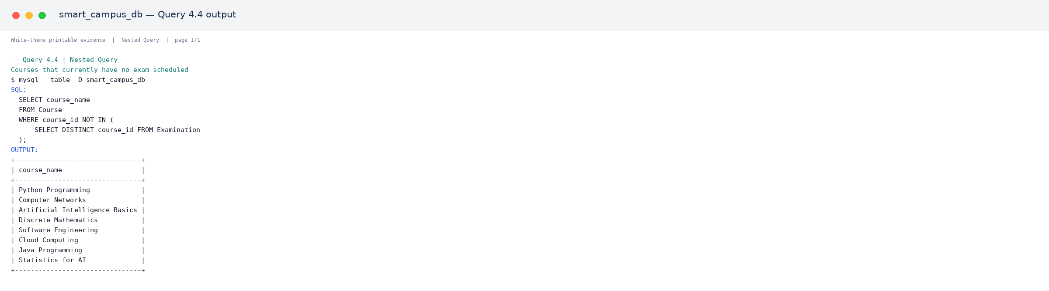
Output 4.4.1. Verified MySQL output for Query 4.4.
[PRINT THIS ASSET: assets/query_outputs/q04_04_nested_query_output_01.png]

PART E – SQL QUERY EVIDENCE

Query 4.5 — Student with the highest marks in each exam (correlated subquery)
Category: Nested Query. Purpose: Student with the highest marks in each exam (correlated subquery). The statement below is taken from the published SQL source.
01 SELECT e.exam_name, s.full_name, r.marks_obtained
02 FROM Result r
03 JOIN Examination e ON r.exam_id = e.exam_id
04 JOIN Student s ON r.student_id = s.student_id
05 WHERE r.marks_obtained = (
06 SELECT MAX(r2.marks_obtained) FROM Result r2 WHERE r2.exam_id = r.exam_id
07 );
08
09
10 -- ***********************************************************
11 -- 5. UPDATE QUERIES (5)
12 -- ***********************************************************

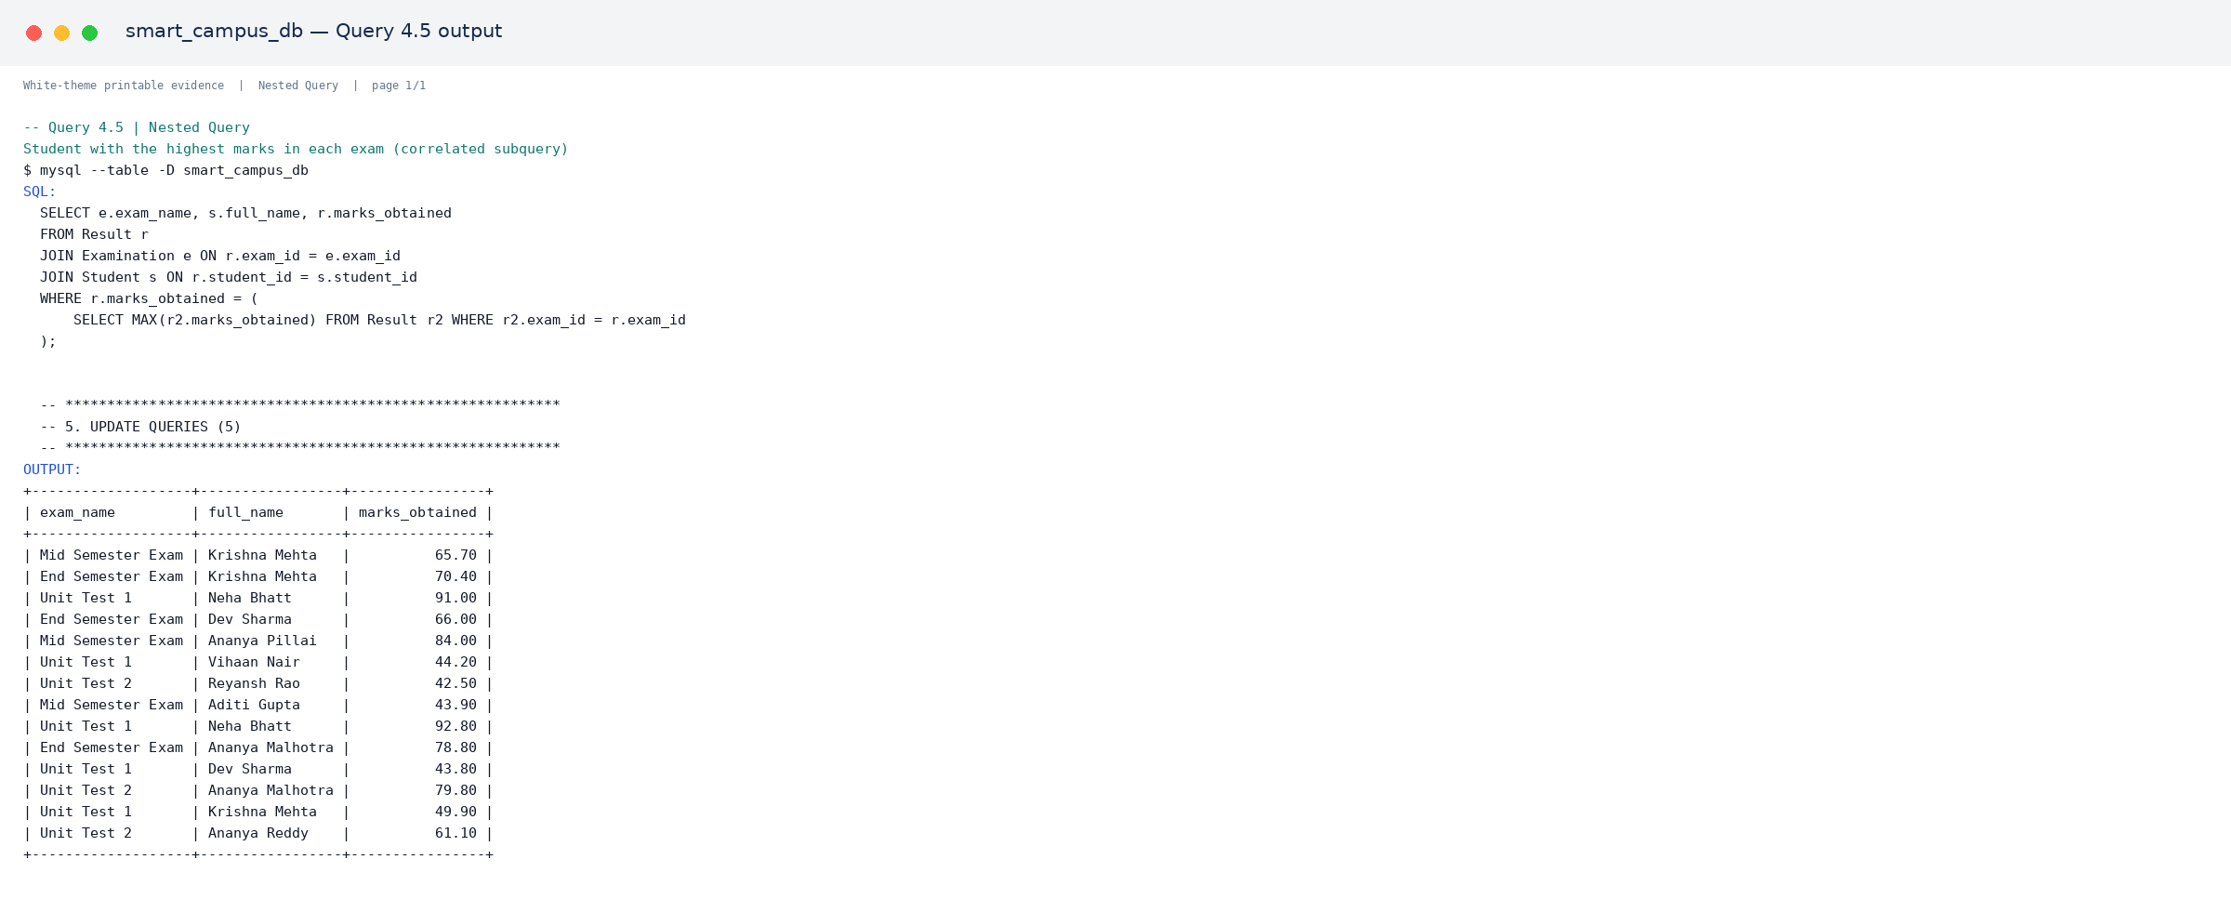
Output 4.5.1. Verified MySQL output for Query 4.5.
[PRINT THIS ASSET: assets/query_outputs/q04_05_nested_query_output_01.png]

Query 5.1 — Update a student's cgpa after result declaration
Category: UPDATE. Purpose: Update a student's cgpa after result declaration. The statement below is taken from the published SQL source.
01 UPDATE Student SET cgpa = 9.10 WHERE roll_no = 'FDAI001';

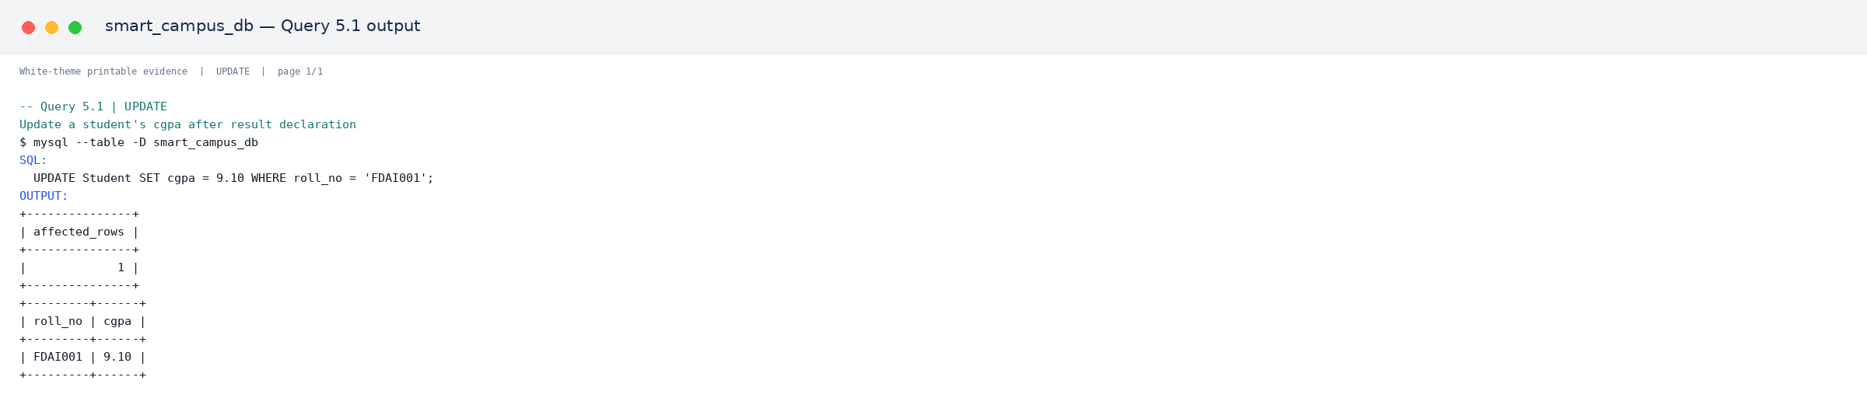
Output 5.1.1. Verified MySQL output for Query 5.1.
[PRINT THIS ASSET: assets/query_outputs/q05_01_update_output_01.png]
Manual-writing note
Write the query purpose and result interpretation. Print the marked output screenshot as evidence; the affected-row or schema result is already visible in the attached asset.

PART E – SQL QUERY EVIDENCE

Query 5.2 — Give a 10% salary hike to all Professors
Category: UPDATE. Purpose: Give a 10% salary hike to all Professors. The statement below is taken from the published SQL source.
01 UPDATE Faculty SET salary = salary * 1.10 WHERE designation = 'Professor';

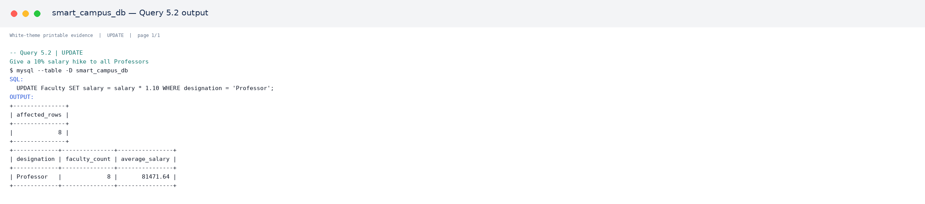
Output 5.2.1. Verified MySQL output for Query 5.2.
[PRINT THIS ASSET: assets/query_outputs/q05_02_update_output_01.png]
Manual-writing note
Write the query purpose and result interpretation. Print the marked output screenshot as evidence; the affected-row or schema result is already visible in the attached asset.

Query 5.3 — Mark a placement application as Selected
Category: UPDATE. Purpose: Mark a placement application as Selected. The statement below is taken from the published SQL source.
01 UPDATE Placement_Record SET status = 'Selected'
02 WHERE student_id = 3 AND drive_id = 2;

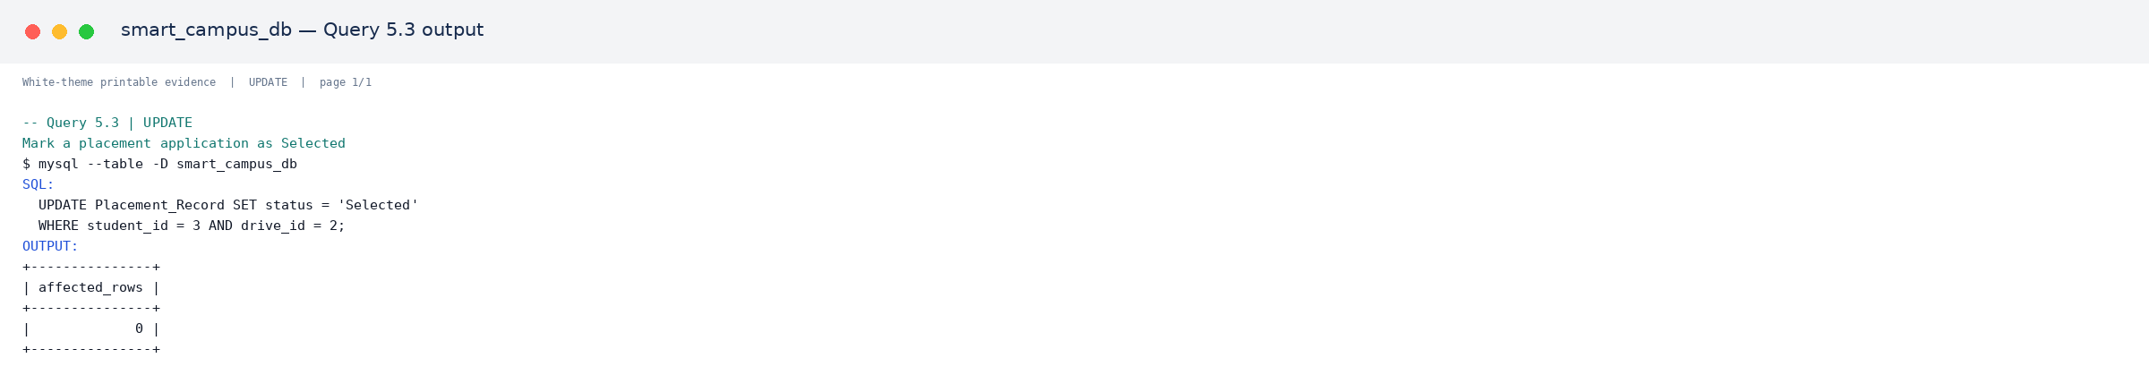
Output 5.3.1. Verified MySQL output for Query 5.3.
[PRINT THIS ASSET: assets/query_outputs/q05_03_update_output_01.png]
Manual-writing note
Write the query purpose and result interpretation. Print the marked output screenshot as evidence; the affected-row or schema result is already visible in the attached asset.

PART E – SQL QUERY EVIDENCE

Query 5.4 — Correct the max marks of an exam
Category: UPDATE. Purpose: Correct the max marks of an exam. The statement below is taken from the published SQL source.
01 UPDATE Examination SET max_marks = 100 WHERE exam_name = 'Unit Test 1' AND max_marks <> 100;

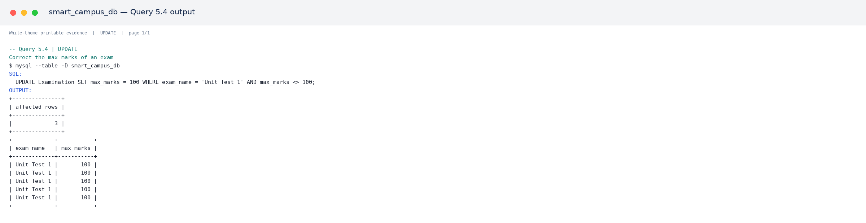
Output 5.4.1. Verified MySQL output for Query 5.4.
[PRINT THIS ASSET: assets/query_outputs/q05_04_update_output_01.png]
Manual-writing note
Write the query purpose and result interpretation. Print the marked output screenshot as evidence; the affected-row or schema result is already visible in the attached asset.

Query 5.5 — Update phone number of a student
Category: UPDATE. Purpose: Update phone number of a student. The statement below is taken from the published SQL source.
01 UPDATE Student SET phone = '9876543210' WHERE roll_no = 'FDAI002';
02
03
04 -- ***********************************************************
05 -- 6. DELETE QUERIES (5)
06 -- ***********************************************************

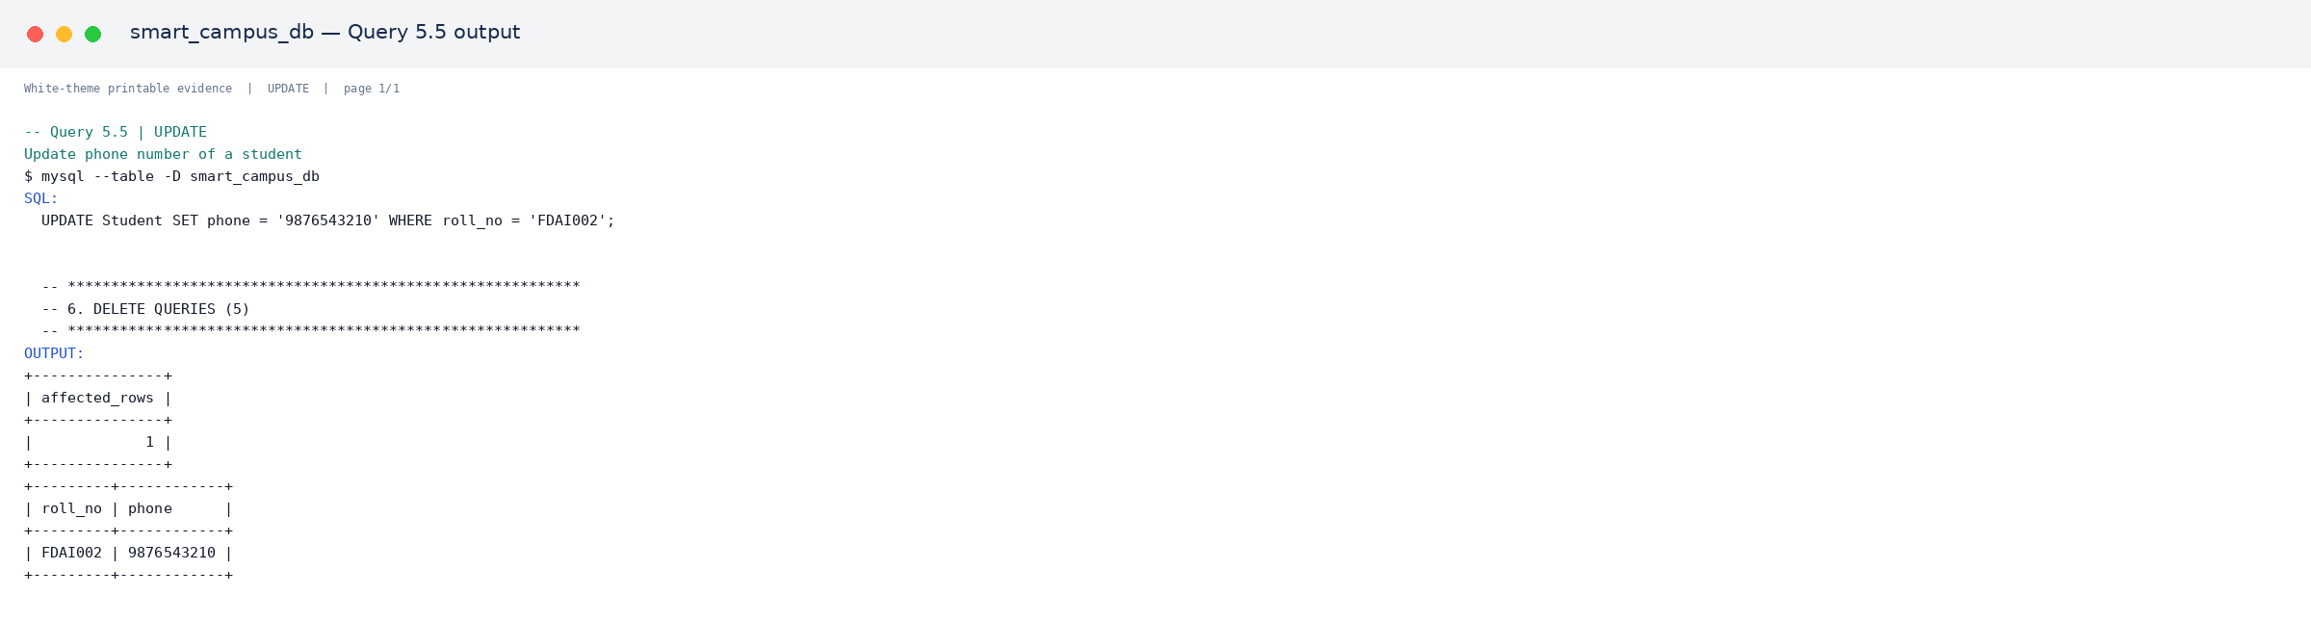
Output 5.5.1. Verified MySQL output for Query 5.5.
[PRINT THIS ASSET: assets/query_outputs/q05_05_update_output_01.png]
Manual-writing note
Write the query purpose and result interpretation. Print the marked output screenshot as evidence; the affected-row or schema result is already visible in the attached asset.

PART E – SQL QUERY EVIDENCE

Query 6.1 — Remove a single wrong attendance entry
Category: DELETE. Purpose: Remove a single wrong attendance entry. The statement below is taken from the published SQL source.
01 DELETE FROM Attendance WHERE attendance_id = 30;

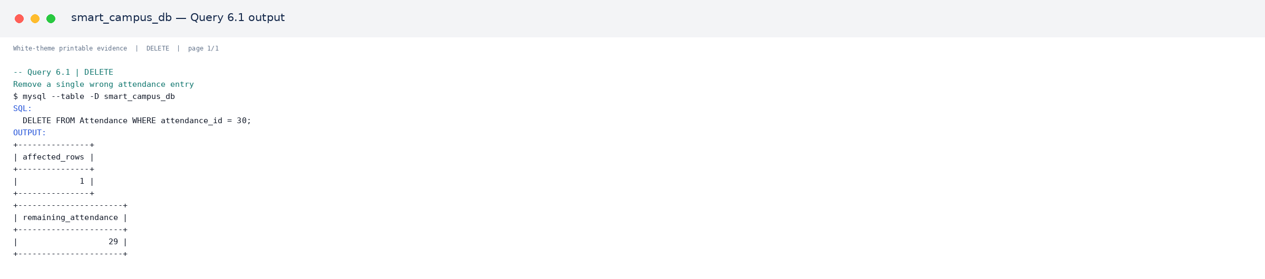
Output 6.1.1. Verified MySQL output for Query 6.1.
[PRINT THIS ASSET: assets/query_outputs/q06_01_delete_output_01.png]
Manual-writing note
Write the query purpose and result interpretation. Print the marked output screenshot as evidence; the affected-row or schema result is already visible in the attached asset.

Query 6.2 — Remove placement applications that were rejected before 2026
Category: DELETE. Purpose: Remove placement applications that were rejected before 2026. The statement below is taken from the published SQL source.
01 DELETE FROM Placement_Record WHERE status = 'Rejected' AND placement_id = 20;

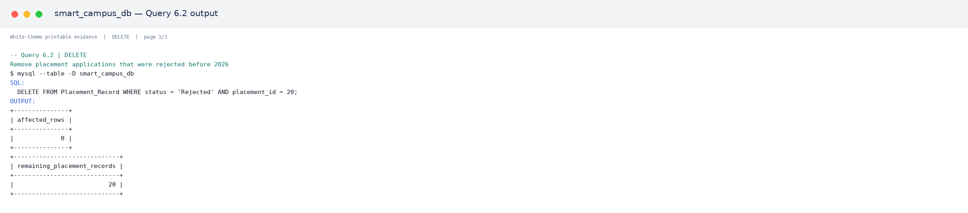
Output 6.2.1. Verified MySQL output for Query 6.2.
[PRINT THIS ASSET: assets/query_outputs/q06_02_delete_output_01.png]
Manual-writing note
Write the query purpose and result interpretation. Print the marked output screenshot as evidence; the affected-row or schema result is already visible in the attached asset.

PART E – SQL QUERY EVIDENCE

Query 6.3 — Remove a faculty record that was entered by mistake (course reassigned first)
Category: DELETE. Purpose: Remove a faculty record that was entered by mistake (course reassigned first). The statement below is taken from the published SQL source.
01 DELETE FROM Faculty WHERE faculty_id = 20;

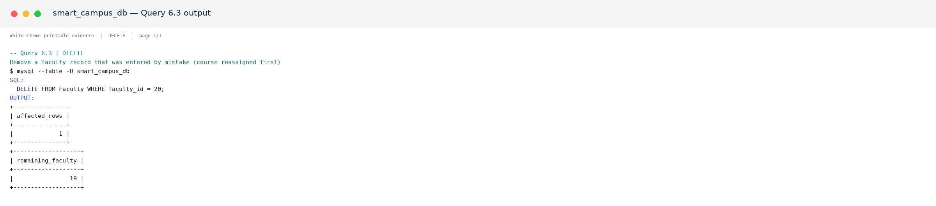
Output 6.3.1. Verified MySQL output for Query 6.3.
[PRINT THIS ASSET: assets/query_outputs/q06_03_delete_output_01.png]
Manual-writing note
Write the query purpose and result interpretation. Print the marked output screenshot as evidence; the affected-row or schema result is already visible in the attached asset.

Query 6.4 — Remove exam records with zero marks entered by mistake
Category: DELETE. Purpose: Remove exam records with zero marks entered by mistake. The statement below is taken from the published SQL source.
01 DELETE FROM Result WHERE marks_obtained = 0;

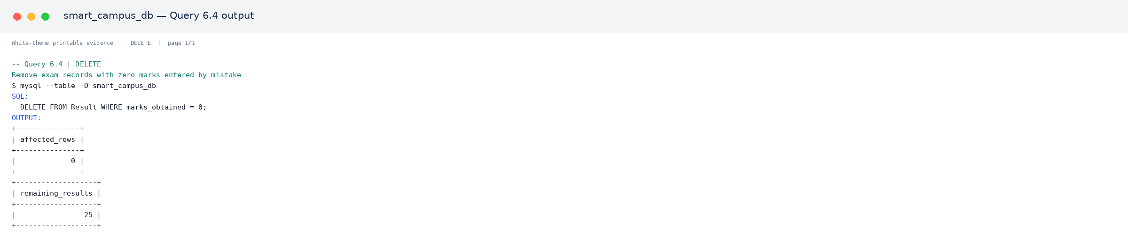
Output 6.4.1. Verified MySQL output for Query 6.4.
[PRINT THIS ASSET: assets/query_outputs/q06_04_delete_output_01.png]
Manual-writing note
Write the query purpose and result interpretation. Print the marked output screenshot as evidence; the affected-row or schema result is already visible in the attached asset.

PART E – SQL QUERY EVIDENCE

Query 6.5 — Remove a placement drive that got cancelled
Category: DELETE. Purpose: Remove a placement drive that got cancelled. The statement below is taken from the published SQL source.
01 DELETE FROM Placement_Drive WHERE drive_id = 15;
02
03
04 -- ***********************************************************
05 -- 7. ALTER TABLE QUERIES (5)
06 -- ***********************************************************

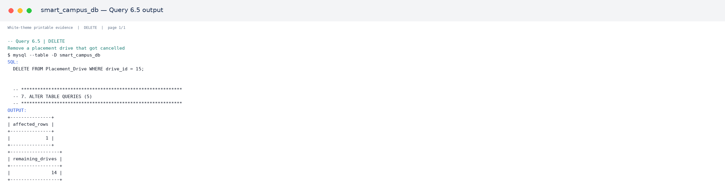
Output 6.5.1. Verified MySQL output for Query 6.5.
[PRINT THIS ASSET: assets/query_outputs/q06_05_delete_output_01.png]
Manual-writing note
Write the query purpose and result interpretation. Print the marked output screenshot as evidence; the affected-row or schema result is already visible in the attached asset.

Query 7.1 — Add a new column to store student's blood group
Category: ALTER TABLE. Purpose: Add a new column to store student's blood group. The statement below is taken from the published SQL source.
01 ALTER TABLE Student ADD COLUMN blood_group VARCHAR(5);

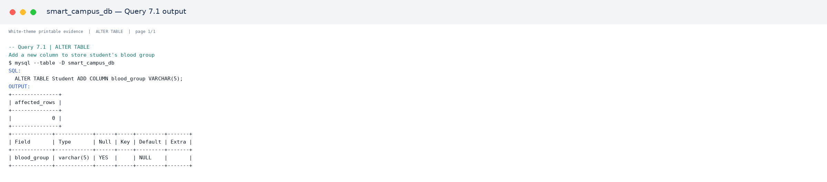
Output 7.1.1. Verified MySQL output for Query 7.1.
[PRINT THIS ASSET: assets/query_outputs/q07_01_alter_table_output_01.png]
Manual-writing note
Write the query purpose and result interpretation. Print the marked output screenshot as evidence; the affected-row or schema result is already visible in the attached asset.

PART E – SQL QUERY EVIDENCE

Query 7.2 — Add a new column to store the mode of a class (Online/Offline)
Category: ALTER TABLE. Purpose: Add a new column to store the mode of a class (Online/Offline). The statement below is taken from the published SQL source.
01 ALTER TABLE Course ADD COLUMN mode VARCHAR(10) DEFAULT 'Offline';

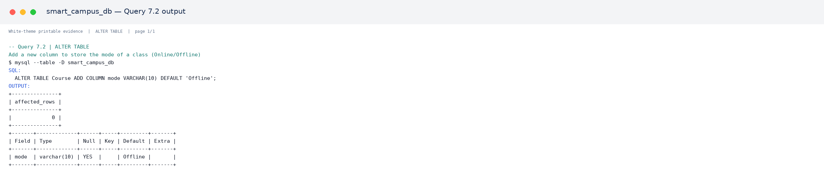
Output 7.2.1. Verified MySQL output for Query 7.2.
[PRINT THIS ASSET: assets/query_outputs/q07_02_alter_table_output_01.png]
Manual-writing note
Write the query purpose and result interpretation. Print the marked output screenshot as evidence; the affected-row or schema result is already visible in the attached asset.

Query 7.3 — Modify phone number column length in Faculty table
Category: ALTER TABLE. Purpose: Modify phone number column length in Faculty table. The statement below is taken from the published SQL source.
01 ALTER TABLE Faculty MODIFY COLUMN phone VARCHAR(20);

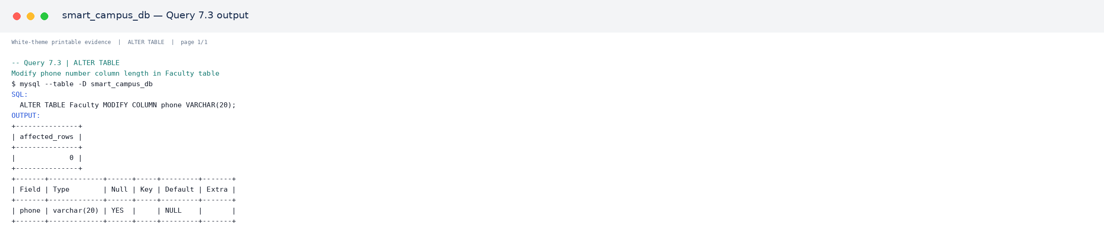
Output 7.3.1. Verified MySQL output for Query 7.3.
[PRINT THIS ASSET: assets/query_outputs/q07_03_alter_table_output_01.png]
Manual-writing note
Write the query purpose and result interpretation. Print the marked output screenshot as evidence; the affected-row or schema result is already visible in the attached asset.

PART E – SQL QUERY EVIDENCE

Query 7.4 — Rename a column in Placement_Drive for clarity
Category: ALTER TABLE. Purpose: Rename a column in Placement_Drive for clarity. The statement below is taken from the published SQL source.
01 ALTER TABLE Placement_Drive RENAME COLUMN package_offered TO package_lpa;

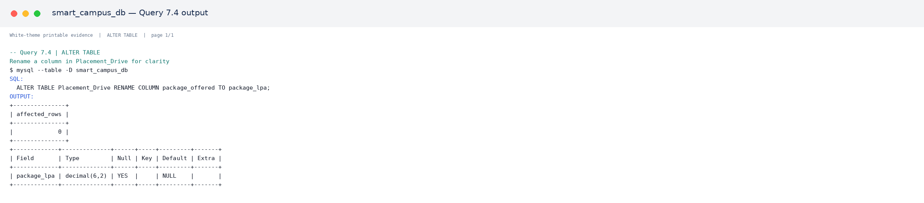
Output 7.4.1. Verified MySQL output for Query 7.4.
[PRINT THIS ASSET: assets/query_outputs/q07_04_alter_table_output_01.png]
Manual-writing note
Write the query purpose and result interpretation. Print the marked output screenshot as evidence; the affected-row or schema result is already visible in the attached asset.

Query 7.5 — Drop the unused blood_group column (shown for reference/undo)
Category: ALTER TABLE. Purpose: Drop the unused blood_group column (shown for reference/undo). The statement below is taken from the published SQL source.
01 ALTER TABLE Student DROP COLUMN blood_group;
02
03
04 -- ***********************************************************
05 -- 8. PATTERN MATCHING QUERIES - LIKE (5)
06 -- ***********************************************************

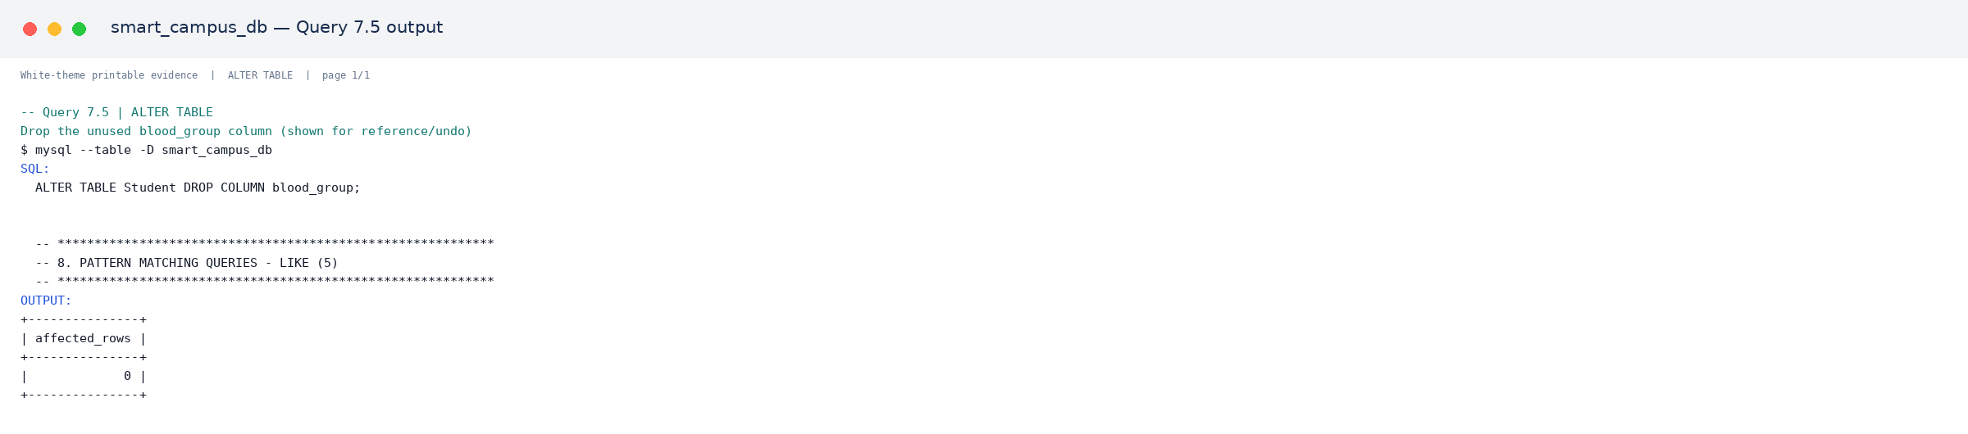
Output 7.5.1. Verified MySQL output for Query 7.5.
[PRINT THIS ASSET: assets/query_outputs/q07_05_alter_table_output_01.png]
Manual-writing note
Write the query purpose and result interpretation. Print the marked output screenshot as evidence; the affected-row or schema result is already visible in the attached asset.

PART E – SQL QUERY EVIDENCE

Query 8.1 — Students whose name starts with 'A'
Category: Pattern Matching (LIKE). Purpose: Students whose name starts with 'A'. The statement below is taken from the published SQL source.
01 SELECT full_name FROM Student WHERE full_name LIKE 'A%';

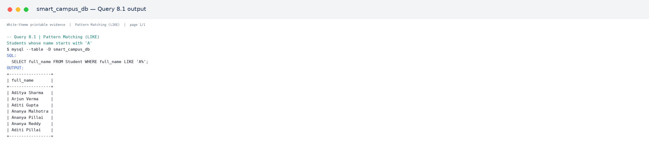
Output 8.1.1. Verified MySQL output for Query 8.1.
[PRINT THIS ASSET: assets/query_outputs/q08_01_like_output_01.png]

Query 8.2 — Faculty whose email is on the campus.edu.in domain
Category: Pattern Matching (LIKE). Purpose: Faculty whose email is on the campus.edu.in domain. The statement below is taken from the published SQL source.
01 SELECT full_name, email FROM Faculty WHERE email LIKE '%@campus.edu.in';

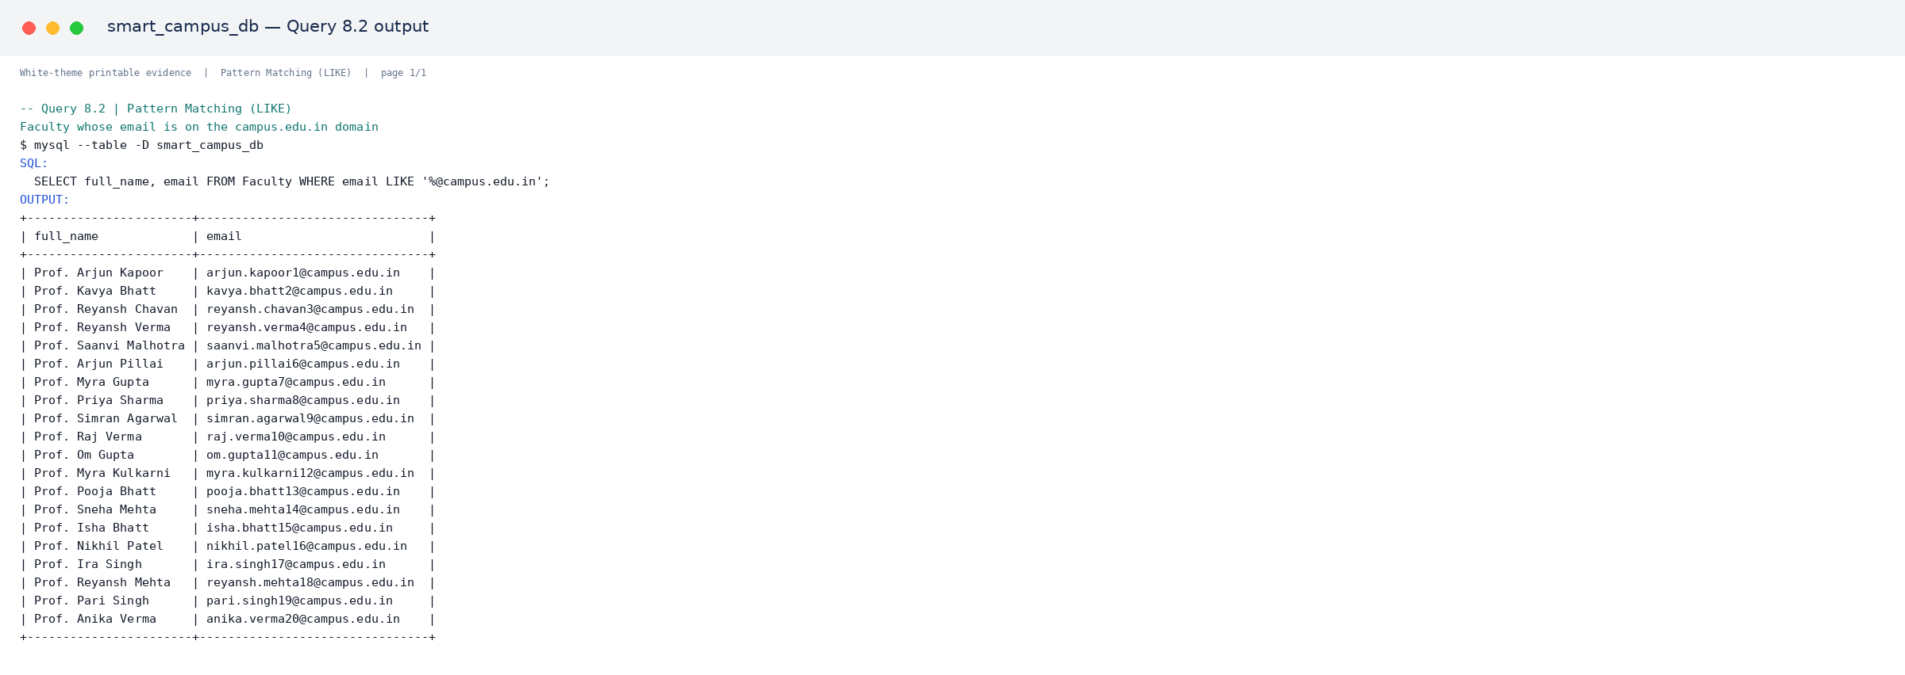
Output 8.2.1. Verified MySQL output for Query 8.2.
[PRINT THIS ASSET: assets/query_outputs/q08_02_like_output_01.png]

PART E – SQL QUERY EVIDENCE

Query 8.3 — Courses with 'Data' anywhere in the course name
Category: Pattern Matching (LIKE). Purpose: Courses with 'Data' anywhere in the course name. The statement below is taken from the published SQL source.
01 SELECT course_name FROM Course WHERE course_name LIKE '%Data%';

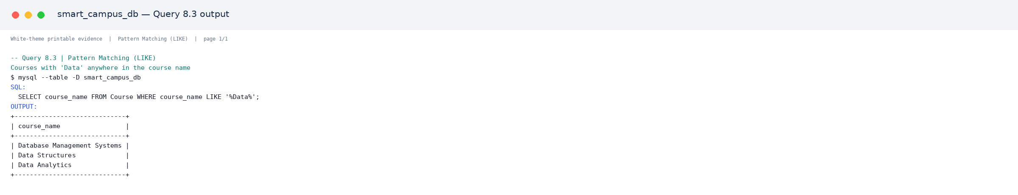
Output 8.3.1. Verified MySQL output for Query 8.3.
[PRINT THIS ASSET: assets/query_outputs/q08_03_like_output_01.png]

Query 8.4 — Companies whose name ends with 'a'
Category: Pattern Matching (LIKE). Purpose: Companies whose name ends with 'a'. The statement below is taken from the published SQL source.
01 SELECT company_name FROM Placement_Drive WHERE company_name LIKE '%a';

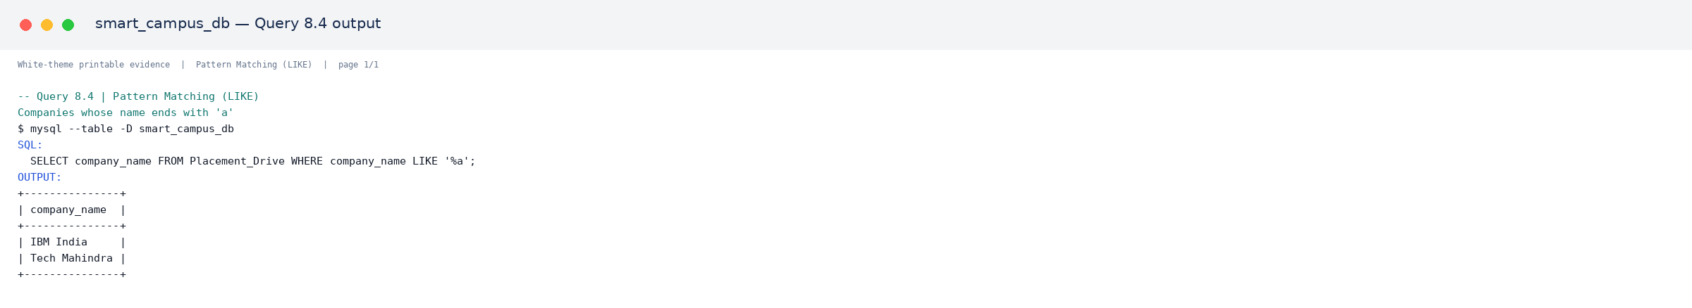
Output 8.4.1. Verified MySQL output for Query 8.4.
[PRINT THIS ASSET: assets/query_outputs/q08_04_like_output_01.png]

Query 8.5 — Students whose roll number matches the pattern FDAI0_1 (2nd last digit is 1)
Category: Pattern Matching (LIKE). Purpose: Students whose roll number matches the pattern FDAI0_1 (2nd last digit is 1). The statement below is taken from the published SQL source.
01 SELECT roll_no, full_name FROM Student WHERE roll_no LIKE 'FDAI0_1';

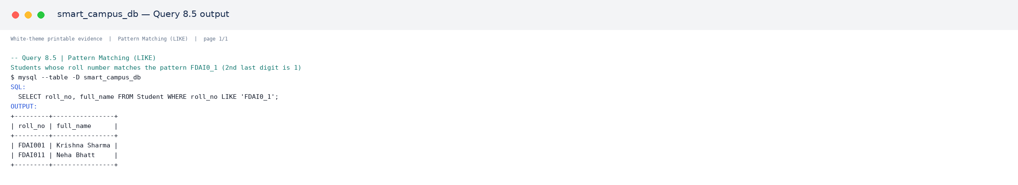
Output 8.5.1. Verified MySQL output for Query 8.5.
[PRINT THIS ASSET: assets/query_outputs/q08_05_like_output_01.png]

PART F – REPORT

F1. Challenges Faced
Challenge | Short solution
Referential integrity | Created parent tables first and used foreign keys.
Duplicate data | Used UNIQUE constraints and 3NF separation.
Child-record handling | Applied ON DELETE CASCADE or SET NULL.
Many query categories | Organized the source into eight clearly labelled groups.
Large evidence volume | Placed every output screenshot in a systematic assets folder.

F2. Learning Outcomes
- Understood requirement analysis, entity identification, relationships, and relational schema design.
- Applied primary keys, foreign keys, unique values, mandatory fields, checks, defaults, and cascading actions.
- Practised retrieval, aggregate, JOIN, nested, UPDATE, DELETE, ALTER TABLE, and LIKE operations.
- Learned to verify SQL output and document query results with reproducible evidence.

F3. Conclusion
The Smart Campus Management System provides a structured relational solution for academic and placement operations. The project satisfies the teacher’s Parts A–F requirements and combines handwritten-friendly explanations with printable SQL and output evidence.

PRESENTATION REFERENCE – 5-MINUTE OUTLINE
The official brief asks for a short presentation reference. The following outline can be used to prepare five concise slides without adding unnecessary written work to the report.
Time | Slide / topic | Key content
0:00–0:45 | Problem and objective | Why a Smart Campus database is required.
0:45–1:30 | Selected modules | Student, Faculty, Attendance, Examination/Result, Placement.
1:30–2:15 | Design | ER diagram, keys, relationships, and 3NF.
2:15–3:30 | Implementation | Nine tables, constraints, seed records, and query categories.
3:30–4:30 | Query evidence | Retrieval, aggregate, JOIN, nested, DML, ALTER, and LIKE examples.
4:30–5:00 | Conclusion | Challenges, learning outcomes, and future scope.

Presentation reminder
Use the report’s ER diagram, workflow, and output screenshots as visual references. The presentation is separate from the handwritten report and SQL printout.

MANUAL WRITING AND PRINTING GUIDE
Use this page as a final preparation guide. The explanatory paragraphs and tables are intended for manual writing; the marked source-code and output screenshots are intended for printing and attachment.
Report part | Write manually | Print and attach
Part A | Objectives, users, functional and non-functional requirements | None required unless teacher asks
Part B | Selected modules, schema explanation, key mapping, 3NF summary | ER and workflow diagrams
Part C | Database setup explanation and constraint meanings | SQL source/code screenshots
Part D | Insert order and data-entry strategy | Optional record-count/output evidence
Part E | Query title, purpose, SQL statement, and short interpretation | The matching output screenshot below every query
Part F | Challenges, learning outcomes, conclusion, references | Final report and selected supporting assets

Asset naming rule
Every screenshot filename begins with the query number, for example q01_01_retrieval_output_01.png. This makes it easy to print the exact file shown below each query.

PRINTABLE ASSET INDEX
The following files are stored systematically inside the assets folder. Print the required files and attach them; do not copy the image filenames into the handwritten body.

Source-Code Screenshots
File | Print marker
code_01_lines_001_048.png | [PRINT THIS ASSET: assets/code_screenshots/code_01_lines_001_048.png]
code_02_lines_049_096.png | [PRINT THIS ASSET: assets/code_screenshots/code_02_lines_049_096.png]
code_03_lines_097_144.png | [PRINT THIS ASSET: assets/code_screenshots/code_03_lines_097_144.png]
code_04_lines_145_192.png | [PRINT THIS ASSET: assets/code_screenshots/code_04_lines_145_192.png]
code_05_lines_193_240.png | [PRINT THIS ASSET: assets/code_screenshots/code_05_lines_193_240.png]
code_06_lines_241_288.png | [PRINT THIS ASSET: assets/code_screenshots/code_06_lines_241_288.png]
code_07_lines_289_336.png | [PRINT THIS ASSET: assets/code_screenshots/code_07_lines_289_336.png]
code_08_lines_337_384.png | [PRINT THIS ASSET: assets/code_screenshots/code_08_lines_337_384.png]
code_09_lines_385_432.png | [PRINT THIS ASSET: assets/code_screenshots/code_09_lines_385_432.png]
code_10_lines_433_480.png | [PRINT THIS ASSET: assets/code_screenshots/code_10_lines_433_480.png]
code_11_lines_481_528.png | [PRINT THIS ASSET: assets/code_screenshots/code_11_lines_481_528.png]
code_12_lines_529_566.png | [PRINT THIS ASSET: assets/code_screenshots/code_12_lines_529_566.png]

Query-Output Screenshot Summary
Query | Asset location
Query 1.1 | 1 output asset(s) — assets/query_outputs/
Query 1.2 | 1 output asset(s) — assets/query_outputs/
Query 1.3 | 1 output asset(s) — assets/query_outputs/
Query 1.4 | 1 output asset(s) — assets/query_outputs/
Query 1.5 | 1 output asset(s) — assets/query_outputs/
Query 1.6 | 1 output asset(s) — assets/query_outputs/
Query 1.7 | 1 output asset(s) — assets/query_outputs/
Query 1.8 | 1 output asset(s) — assets/query_outputs/
Query 1.9 | 1 output asset(s) — assets/query_outputs/
Query 1.10 | 1 output asset(s) — assets/query_outputs/
Query 2.1 | 1 output asset(s) — assets/query_outputs/
Query 2.2 | 1 output asset(s) — assets/query_outputs/
Query 2.3 | 1 output asset(s) — assets/query_outputs/
Query 2.4 | 1 output asset(s) — assets/query_outputs/
Query 2.5 | 1 output asset(s) — assets/query_outputs/
Query 3.1 | 2 output asset(s) — assets/query_outputs/
Query 3.2 | 1 output asset(s) — assets/query_outputs/
Query 3.3 | 1 output asset(s) — assets/query_outputs/
Query 3.4 | 1 output asset(s) — assets/query_outputs/
Query 3.5 | 1 output asset(s) — assets/query_outputs/
Query 4.1 | 1 output asset(s) — assets/query_outputs/
Query 4.2 | 1 output asset(s) — assets/query_outputs/
Query 4.3 | 1 output asset(s) — assets/query_outputs/
Query 4.4 | 1 output asset(s) — assets/query_outputs/
Query 4.5 | 1 output asset(s) — assets/query_outputs/
Query 5.1 | 1 output asset(s) — assets/query_outputs/
Query 5.2 | 1 output asset(s) — assets/query_outputs/
Query 5.3 | 1 output asset(s) — assets/query_outputs/
Query 5.4 | 1 output asset(s) — assets/query_outputs/
Query 5.5 | 1 output asset(s) — assets/query_outputs/
Query 6.1 | 1 output asset(s) — assets/query_outputs/
Query 6.2 | 1 output asset(s) — assets/query_outputs/
Query 6.3 | 1 output asset(s) — assets/query_outputs/
Query 6.4 | 1 output asset(s) — assets/query_outputs/
Query 6.5 | 1 output asset(s) — assets/query_outputs/
Query 7.1 | 1 output asset(s) — assets/query_outputs/
Query 7.2 | 1 output asset(s) — assets/query_outputs/
Query 7.3 | 1 output asset(s) — assets/query_outputs/
Query 7.4 | 1 output asset(s) — assets/query_outputs/
Query 7.5 | 1 output asset(s) — assets/query_outputs/
Query 8.1 | 1 output asset(s) — assets/query_outputs/
Query 8.2 | 1 output asset(s) — assets/query_outputs/
Query 8.3 | 1 output asset(s) — assets/query_outputs/
Query 8.4 | 1 output asset(s) — assets/query_outputs/
Query 8.5 | 1 output asset(s) — assets/query_outputs/

Final submission checklist
Attach the complete SQL file, the marked code/output screenshots, and this DOCX reference report. The README.md in the project root mirrors this documentation for GitHub users.

REFERENCES
[1] Teacher-provided assignment brief: FYAIDBMSASSIGNMENT.pdf.
[2] Published project source: https://github.com/codeXparadise/Assignments/tree/main/DBMS/UNIT%201.
[3] MySQL 8.0 Reference Manual: https://dev.mysql.com/doc/refman/8.0/en/.
[4] Third Normal Form reference: https://en.wikipedia.org/wiki/Third_normal_form.
Prepared as a student reference document for the Smart Campus Management System DBMS assignment.

